DRAFT
PROVISIONAL AGENDA
The pre-SOM & 14th CTI-CFF Senior Officials’ Meeting
(SOM-14)

10 – 13 December 2018
Makati City, Philippines
INFORMATION

Venue:

The 14th Coral Triangle Initiative on Coral Reefs, Fisheries and Food Security Senior Officials Meeting (14 CTI-CFF SOM) will be held at Dusit Thani Manila Hotel, Makati City, Philippines. The management of the said Hotel may be contacted at the following:

Address: 1223 Epifanio de los Santos Ave., Makati City, Metro Manila, Philippines

Website: https://www.dusit.com/dusitthani/manila/
Tel. No. +63 (2) 238 8888
Fax No. +63 (2) 238 8800
Email: dtmn@dusit.com
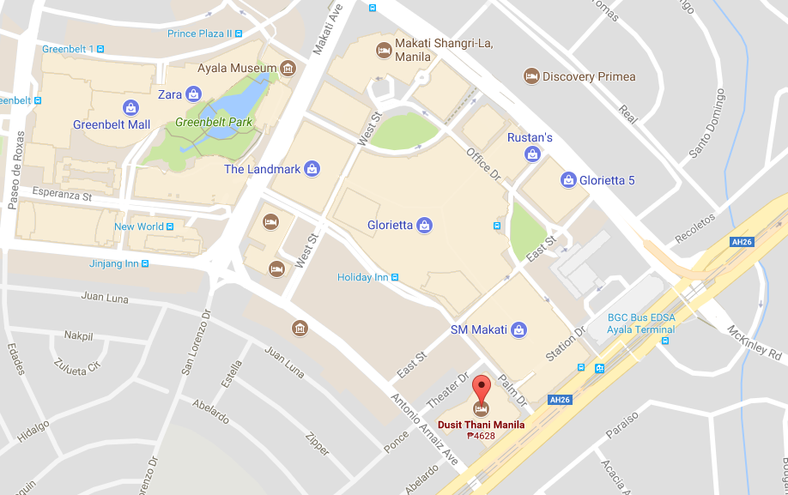

Organizing Committee of National Coordination Committee (NCC) of the Philippines

NCC Philippines  Name: Ms. Nilda S. Baling  Position/Department: Supervising Ecosystems Management Specialist  Email:nildasbaling@yahoo.com  Mobile No: +63 9088935863 | NCC Philippines  Name: Mr. Pablo G. de los Reyes Jr.  Position/Department: Senior Ecosystems Management Specialist  Email: ogie821@gmail.com  Mobile No: +63 9661795022
NCC Philippines  Name: Ms. Carina Manlapaz  Position/Department: Ecosystems Management Specialist  Email: carinamanlapaz@gmail.com  Mobile No: +63 9276066971 | NCC Philippines  Name: Mr. John Erick Avelino  Position/Department: Ecosystems Management Specialist  Email: avelinojohnerick@gmail.com  Mobile No: +63 9674004621

OBJECTIVES OF SOM-14

Day 1 (Wednesday, 12 December 2018)

- Officially opens the SOM-14
- Acknowledge and accept 2018 Progress Report
- Accept Chair of the Committee of Senior Officers (CTI-CSO) report and acknowledge handover of duty to the next Chair
- Accept and advise further amendments to the Agreement of the Establishment of CTI-CFF (incl. the Financial and Staff Regulations and its accompanying rules)
- Acknowledge and agree to the appointment process of new Executive Director and Deputy Executive Director for Corporate Services
- Discuss and agree on the findings of the Review of the CTI-CFF Regional Plan of Action, the proposed Terms of Reference for RPOA 2.0 and its governance framework
- Participate in Partners’ Dialogue focusing on future of CTI-CFF
- Accept and agree on Regional Secretariat’s financial reports (incl. audit reports, financial statement for 2018, country contributions and budgets for 2019 and 2020

Day 2 (Thursday, 13 December 2018)

- Accept and agree to the reports by the five (5) Technical Working Group(s) incl. its roadmap and budget;
- Accept and agree to the reports by the three (3) Governance Working Groups incl. its recommendations and budget;
- Acknowledge and accept reports from CT6 Member Parties (Country Reports) including its challenges and potential regional actions / programs;
- Acknowledge, accept and deliberate report from the cross-cutting themes and potential mainstreaming efforts into CTI-CFF programs;
- Deliberate and accept the proposed calendar of events for 2019 prepared by the Regional Secretariat on potential high impact events to profile CTI-CFF;
- Accept the proposed agenda for the 7th Ministerial Meeting;
- Acknowledge and accept the venue and date for the next 15th Senior Official’s Meeting (SOM-15)
- Agree and adopt the SOM-14 Chairman Summary

The pre-SOM meetings schedule
10-11 December 2018
Dusit Thani Manila Hotel, Makati City, Philippines

TIME | DAY 1 / 10 DEC |  |  | DAY 2 / 11 DEC
 | ROOM A | ROOM B | ROOM C | ROOM A | ROOM B | ROOM C
8:30-9:00 |  |  | MEWG (Plenary) |  |  | FRWG (Plenary)
9:00-9:30
9.30-10.00
10.00-10.30
10:30-10:45 | Break | Break | Break | Break | Break | Break
10:45-11:15 |  |  | RPOA 2.0 |  | EAFM | CMWG (Plenary)
11:15-11:45 |  |  |  |  | EAFM
11.45-12.15 |  |  |  |  | EAFM
12.15-12.45 |  |  |  |  | EAFM
12:45-1.45 | Lunch | Lunch | Lunch | Lunch | Lunch | Lunch
1:45-2:15 | LGN | CCA |  | SAG/UP | MPA
2.15-2.45 | LGN | CCA |  | SAG/UP | MPA
2.45-3.15 | LGN | CCA |  | SAG/UP | MPA
3.15-3.45 | LGN | CCA |  | SAG/UP | MPA
3.45-4.00 | Break | Break | Break | Break | Break | Break
4.00-4.30 | WLF | SEASCAPE |  | RBF/OOC | TSWG
4.30-5.00 | WLF | SEASCAPE |  | RBF/OOC | TSWG
5.00-5.30 | WLF | SEASCAPE |  | RBF/OOC | TSWG
5.30-6.00 | WLF | SEASCAPE

PROVISIONAL AGENDA
The 14th CTI-CFF Senior Officials’ Meeting (SOM-13)
12-13 December 2018
Dusit Thani Manila Hotel, Makati City, Philippines

Chair: H.E. Atty. Jonas R. Leones
Undersecretary for Policy, Planning and International Affairs
Department of Environment and Natural Resources of the Philippines

DAY 1
12 DECEMBER 2018

No | ACTIVITY | TIME | ACTION
SESSION 1. OPENING CEREMONY BY HOST COUNTRY
Co-Chair: Philippines
1.2 | Opening and Welcome Remarks from Chair CSO | 09:00 - 09:10 | Chair of CSO
1.3 | Round of Introduction | 09:10 - 09:20 | Chair of CSO
1.4 | Adoption of Agenda & co-chairs of sessions | 09:20 - 09:30 | Chair of CSO
1.5 | Photo Session | 09:30 - 09:45 | Chair of CSO
SESSION 2. CTI-CFF PROGRESS REPORT
Co-Chair: Solomon Islands
2.1 | Summary Progress Report | 09:45 - 10:15 | Interim Executive Director (Regional Secretariat)
2.2 | Deliberation & acceptance of Progress Report | 10:15 - 10:30 | CT6 & Partners
 | Coffee Break | 10:30 - 10:45 | Organizing Committee
SESSION 3. CHAIR REPORT
Co-Chair: Timor-Leste
3.1 | Chair Report from Chair of CSO (and acknowledgement of handover of duty of CSO and COM Chair) | 10:45 - 11:00 | Chair of CSO
3.2 | Deliberation & acceptance of Chairman’s Report | 11:00 - 11:15 | CT6
SESSION 4. AMENDMENTS TO CTI-CFF Rules and Regulations, and Rules of Procedures
Co-Chair: Indonesia
4.1 | Summary Changes to Staff Regulation & Rules and Procedures (as discussed in pre-SOM CMWG) | 11:15 – 11:45 | Corporate Services (Regional Secretariat)
4.2 | Summary Presentation on Financial Regulations & Rules and Procedures (as discussed in pre-SOM FRWG) | 11:45 – 12:15 | Corporate Services (Regional Secretariat)
4.3 | Deliberation and acceptance for COM endorsement | 12:15 – 12:30 | CT6
 | Lunch | 12:30 - 13:30 | Organizing Committee
SESSION 5. APPOINTMENT PROCESS OF EXECUTIVE DIRECTOR AND DEPUTY EXECUTIVE DIRECTOR FOR CORPORATE SERVICES
Chair: Malaysia
5.1 | Report on status of Appointment Process | 13:30 - 13:40 | Chair of Appointment Committee / Regional Secretariat
5.2 | Presentation of Proposed 2019 Organization Chart | 13:40 - 13:50 | CT6
5.3 | Deliberation and acceptance of Status Report | 13:50 - 14:00 | CT6
SESSION 6. FUTURE OF CTI-CFF: RPOA 2.0
Chair: Philippines
6.1 | Review of RPOA Presentation and recommendations | 14:00 - 15:00 | Presentation by RPOA Consultant
6.2 | Reflections on the RPOA Review from Development Partners | 15:00 - 15:40 | US Government, Australian Government, ADB, CTC, TNC, CI, WWF, GIZ, SPREP and SEAFDEC
6.3 | Discussion between CTI and Development Partners on the CTI present and future | 15:40 - 16:40 | CT6 and Development Partners
6.4 | Acceptance of discussion | 16:40 - 16:50 | CT6 and Development Partners
SESSION 7. REGIONAL SECRETARIAT'S FINANCIAL REPORT
Chair: Papua New Guinea
7.1 | Report on 2015 - 2017 audits | 16:50 - 17:50 | Corporate Services (Regional Secretariat)
7.2 | 2018 Expense Report |  | Corporate Services (Regional Secretariat)
7.3 | 2019 & 2020 Proposed Operational Plan & Budget |  | Corporate Services (Regional Secretariat)
7.4 | Report on Country Contribution |  | Corporate Services (Regional Secretariat)
7.5 | Deliberation and acceptance for COM endorsement | 17:50 - 18:00 | CT6
END OF DAY 1

DAY 2
13 DECEMBER 2018

No | ACTIVITY | TIME | ACTION
SESSION 8. TECHNICAL WORKING GROUPS REPORT, ROADMAP & BUDGET
Chair: Timor-Leste
8.1 | Seascape Working Group | 08:30 - 08:40 | Chair of Seascape WG
8.2 | EAFM Working Group | 08:40 - 08:50 | Chair of EAFM WG
8.3 | MPA Working Group | 08:50 - 09:00 | Chair of MPA WG
8.4 | CCA Working Group | 09:00 - 09:10 | Chair of CCA WG
8.5 | Threatened Species Working Group | 09:10 - 09:20 | Chair of TSWG
8.6 | Acknowledgement and acceptance for COM endorsement | 09:20 - 09:30 | CT6
SESSION 9. GOVERNANCE WORKING GROUPS REPORT AND ROADMAP
Chair: Indonesia
9.1 | Coordination Mechanism WG | 09:30 - 09:40 | Chair of CMWG
9.2 | Financial Resources WG | 09:40 - 09:50 | Chair of FRWG
9.3 | Monitoring & Evaluation WG (incl. Review of RPOA Report) | 09:50 -10:20 | Chair of MEWG
9.4 | Acknowledgement and acceptance for COM endorsement | 10:20 - 10:30 | CT6 & Partners
 | Tea Break | 10:30 - 10:45 | Organizing Committee
SESSION 10. COUNTRY REPORTS (CHALLENGES AND REGIONAL ACTIONS)
Chair: Malaysia
10.1 | Country Report Presentations | 10:45 - 11:00 | NCC Indonesia
10.2 | Country Report Presentations | 11:00 - 11:15 | NCC Malaysia
10.3 | Country Report Presentations | 11:15 - 11:30 | NCC Papua New Guinea
10.4 | Country Report Presentations | 11:30 - 11:45 | NCC Philippines
10.5 | Country Report Presentations | 11:45 - 12:00 | NCC Solomon Islands
10.6 | Country Report Presentations | 12:00 - 12:15 | NCC Timor-Leste
10.7 | Acknowledgement and acceptance for COM endorsement | 12:15- 12:30 | CT6 & Partners
 | Lunch | 12:30 - 13:30 | Organizing Committee
SESSION 11. CROSS CUTTING THEMES
Chair: Papua New Guinea
11.1 | Women Leaders Forum | 13:30 - 13:40 | Chair of WLF
11.2 | Local Government Network | 13:40 - 13:50 | Chair of LGN
11.3 | Scientific Advisory Group & University Partnership | 13:50 - 14:00 | Program Services (Regional Secretariat)
11.4 | Capacity Building | 14:00 - 14:10 | Program Services (Regional Secretariat)
11.5 | RBF / OOC Outcome - CTI Pledge | 14:10 - 14:20 | Program Services (Regional Secretariat)
11.6 | Acknowledgement and acceptance for COM endorsement | 14:20 - 14:30 | CT6 & Partners
SESSION 12. 2019 CALENDAR OF EVENTS
Chair: Papua New Guinea
12.1 | High Impact Events for CTI in 2019 | 14:30 - 14:40 | Program Services (Regional Secretariat)
12.2 | Deliberation and acceptance for COM endorsement | 14:40 - 14:50 | CT6 & Partners
SESSION 13. AGENDA FOR THE 7th MINISTERIAL MEETING (MM-7)
Chair: Philippines
13.1 | Presentation of draft agenda | 14:50 - 15:00 | Interim Executive Director (Regional Secretariat)
13.2 | Presentation of draft Joint Ministerial Statement (JMS) | 15:00 - 15:15 | Interim Executive Director (Regional Secretariat)
13.3 | Adoption of proposed draft agenda and JMS | 15:15 - 15:20 | CT6 & Partners
SESSION 14. 15th SENIOR OFFICIALS' MEETING (SOM-15)
Chair: Solomon Islands
14.1 | Venue and tentative date for SOM-15 | 15:20 - 15:30 | CT6
14.2 | Agree for COM endorsement | 15:30 - 15:40 | CT6
SESSION 15. OTHER MATTERS
Chair: Timor-Leste
15.1 | CTI-CFF Regional Secretariat registration with the UN Secretary General | 15:40 - 15:50 | CT6 & Partners
 | Tea Break | 15:50 - 16:30 | Organizing Committee
SESSION 16. REVIEW CHAIRMAN SUMMARY & CLOSING
Chair: Philippines
16.1 | Review and deliberate on draft Chairman Summary | 16:30 - 17:00 | Chair of CSO
16.2 | Agree for COM endorsement | 17:00 - 17:10 | CT6
16.3 | Signing of Chairman Summary | 17:10 - 17:20 | CT6
16.4 | Closing of Meeting | 17:20 - 17:30 | Chair of CSO
 | END OF SOM-14 |  | END OF SOM-14

