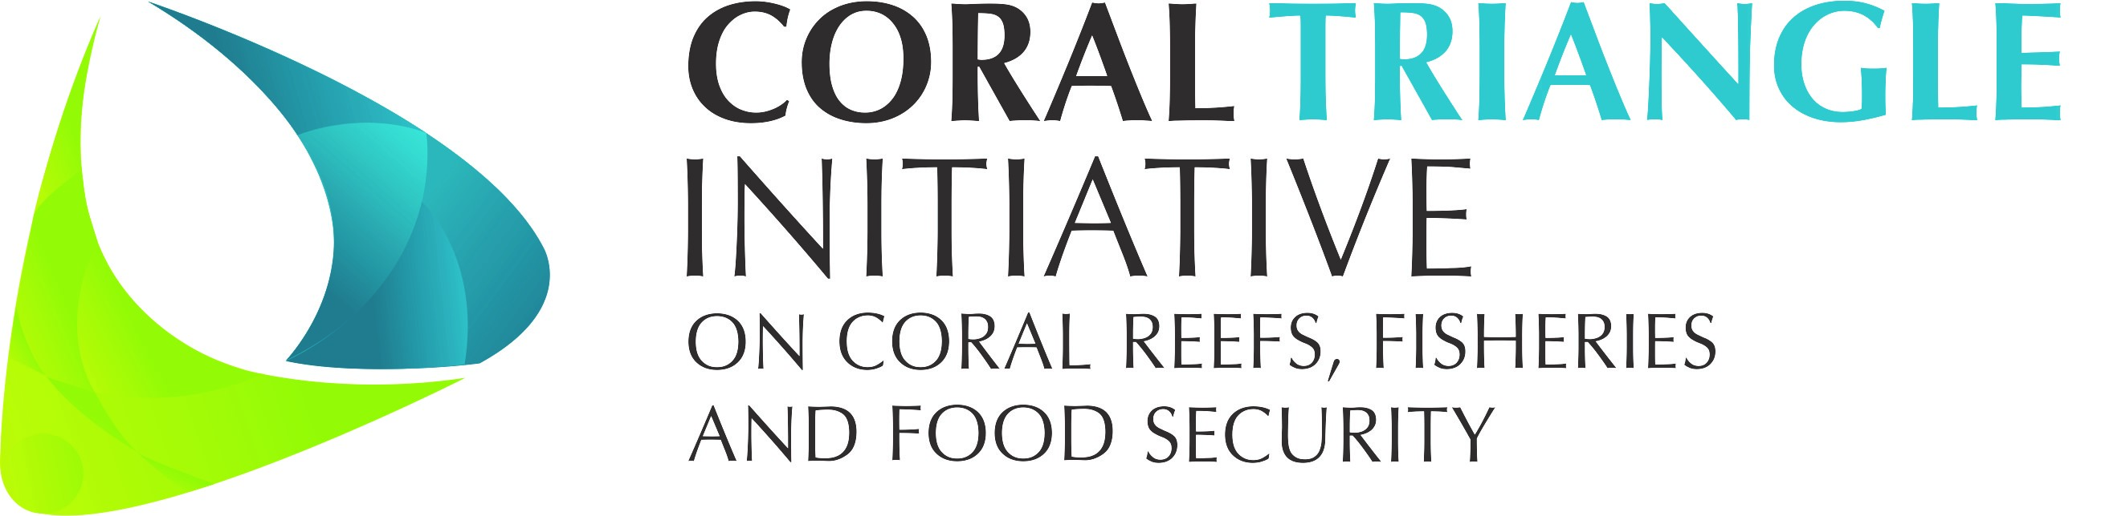

DRAFT Decision Document on

Session 9

Capacity Building
___________________

The 13th CTI-CFF SENIOR OFFICIALS’ MEETING (SOM-13)

29 – 30 November 2017
Dusit Thani Manila Hotel
Makati City, Philippines

Adopted on 29 - 30 November 2017
by
the Governments of Indonesia, Malaysia, Papua New Guinea,
the Philippines, Solomon Islands, and Timor-Leste

I. Background

As early as the 6th Senior Officials’ Meeting (SOM-6), the need for improvement in institutional and human capacity was identified. Over the next few Senior Officials Meeting, decisions were made to ensure progress of improving human capacity is maintained. There were:
SOM – 6 (2010) Agreement that Capacity Building support for each goal is to be hosted under the relevant TWGs (i.e. no separate working group for capacity building).
SOM – 10 (2014) The need was identified for collating/summarizing existing capacity building needs and efforts underway under each goal to address these needs; and to identify gaps / areas of support needed.
SOM – 11 (2015) Mandate for CTI-RS and CTC to undertake capacity building assessment.
With the support from USAID-RDMA, US-Department of Interior & Sustainable Solutions International Consulting), a Capacity Building Assessment Report for Goal 3 “Marine Protected Areas Established and Effectively Managed” has been commissioned and completed*.

One of the SOM-12 decision that have yet to be implemented is:
12.5.5. Agreed to replicate this assessment approach for the remaining four goals for the CTI-CFF RPOA to:
12.5.5.1. Recognized that assessing the capacity building status for Goal # 3 (MPAs) is only one incremental step in assessing the capacity building status for all five RPOA goals;
12.5.5.2. Recommend: the remaining four goals be assessed using a similar methodology and approach, to develop the full technical series of assessments, as already mandated in SOM-11.

Since SOM-12, the Regional Secretariat have been in communication with the Environmental Defense Fund (EDF) to explore potential collaboration in fisheries management capacity building programs.

Youth programs were also discussed in during SOM-12 and the Regional Secretariat have taken steps towards assessing potential youth programs with existing and relevant youth organizations such as with the ADB Youth for Asia and the U.S. Mission to ASEAN chapter on youth leadership programs.

II. Decisions

Referring to the discussion and consideration among the SOM-13 in session ten (10) in relation to the Cross Cutting Themes on Capacity Building, the Senior Officials hereby:

- Acknowledged on progress made to improve human capacity for all CTI goals;
- Acknowledged and recommended for the proposed collaborations with the Environmental Defence Fund (EDF) on fishery management to be implemented with coordination efforts from the Regional Secretariat; and
- Acknowledged and recommended for the Regional Secretariat to continue working with relevant youth organizations to empower youth in the CTI region.

Annex:

- Capacity Building presentation;
- Capacity Building Assessment Report for Goal 3 “Marine Protected Areas Established and Effectively Managed”

