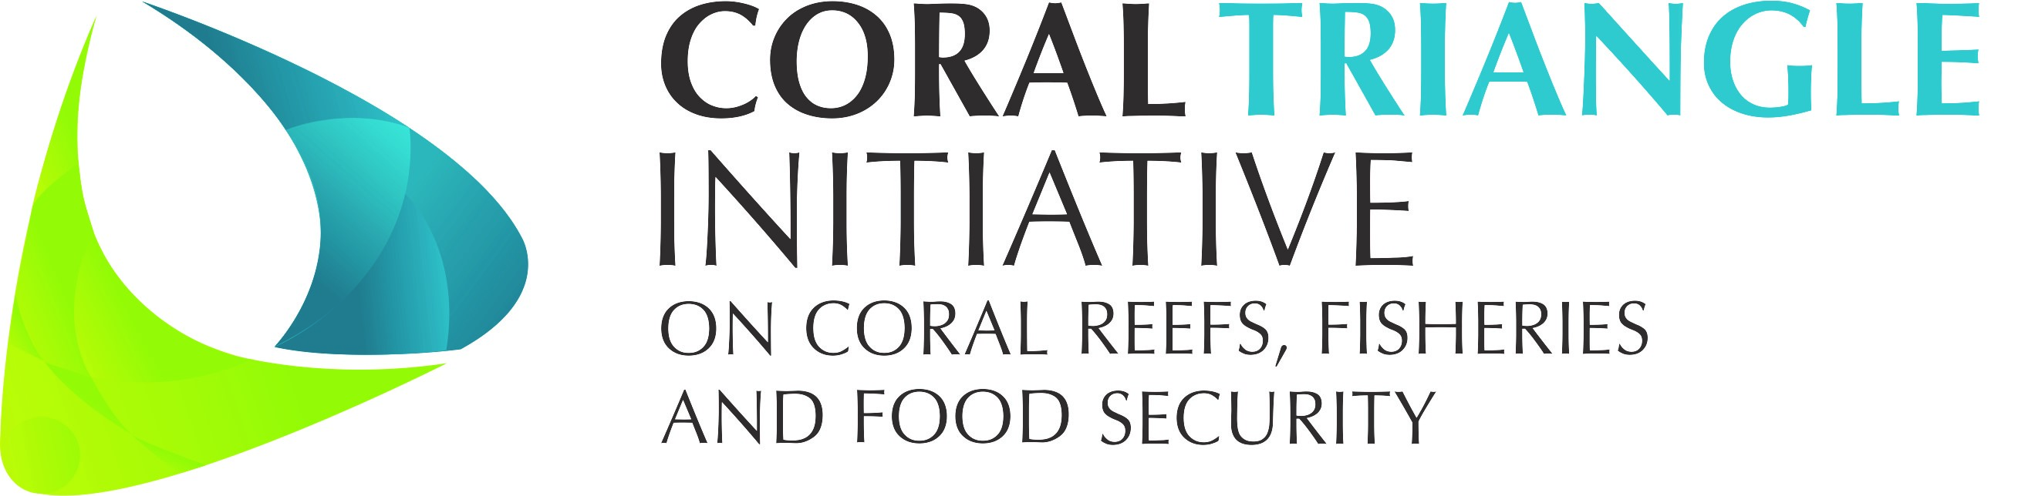

DRAFT Decision Document on

Session 10

Scientific Advisory Group (SAG)
___________________

The 13th CTI-CFF SENIOR OFFICIALS’ MEETING (SOM-13)

29 – 30 November 2017
Dusit Thani Manila Hotel
Makati City, Philippines

Adopted on 29 - 30 November 2017
by
the Governments of Indonesia, Malaysia, Papua New Guinea,
the Philippines, Solomon Islands, and Timor-Leste

I. Background

The Council of Senior Officers acknowledged the critical need for process of decision-making to be backed by good and best available science. Since the 10th Senior Officials’ Meeting (SOM-10) in 2014, recommendations were made for the establishment of the Scientific Advisory Group (SAG).

SOM-12 decisions include:

12.6.1. Acknowledged the progress made by the Regional Secretariat with regards to the establishment of the Scientific Advisory Group (SAG);
12.6.2. Agreed to initiate the process of the Scientific Advisory Group (SAG) establishment based on the proposed approaches;
12.6.3. Proposed for the members of the initial SAG to be derived based on thematic issues / ad-hoc basis as per required in the implementation of CTI-CFF frameworks such as CTMPAS, CCA-REAP, M&E System etc.;
12.6.4. Proposed for the members of the initial SAG to include experts in the various programs / projects undertaken or are in the process of implementation by the Regional Secretariat and / or Development Partners to leverage on the respective programs’ financial support;
12.6.5. Proposed for the members of the initial SAG to include relevant experts from higher learning institutions / research organizations / regional and international organizations that have signed MOUs with the Regional Secretariat;
12.6.6. Acknowledged the CTI-CFF/USAID-DOI Regional Secretariat Work Plan for Strengthening Organizational and Administrative Capacity for Improved Fisheries Management, as the initial approach towards the establishment of the Scientific Advisory Group (SAG); and
12.6.7. Encouraged the Regional Secretariat to work with all Technical Working Groups to evaluate the draft “Mechanism of the Utilization of Experts to the establishment of the Scientific Advisory Group” and “CTI-CFF Experts Form” and amend where necessary for SOM-13 approval.

Since SOM-12, discussions in relation to the establishment and financing of the Scientific Advisory Group (SAG) took place in the CTI-CFF University Partnership meetings. The NCCs agreed that the SAG shall be a crucial “scientific” arm of the CTI.
Support to initiate and operationalize the SAG-EAFM has been planned under the USAID-Department of Interior program.

II. Decision

Referring to the discussion and consideration among the SOM-13 in session ten (10) in relation to the Cross Cutting Themes on Scientific Advisory Group (SAG), the Senior Officials hereby:

- Endorsed the Mechanism of the Utilization of Experts to the establishment of the Scientific Advisory Group”;
- Endorsed the CTI-CFF Experts Form;
- Endorsed the Terms of Reference for the Scientific Advisory Group;
- Acknowledged and agreed to the plan for the first meeting of the SAG-EAFM under the CTI-CFF / USAID-DOI “Strengthening Organizational and Administrative Capacity for Improved Fisheries Management (SOACAP-IFM)”; and
- Endorsed the 2018 Workplan

Annex:

- SAG presentation
- Terms of Reference for the Scientific Advisory Group (SAG)

