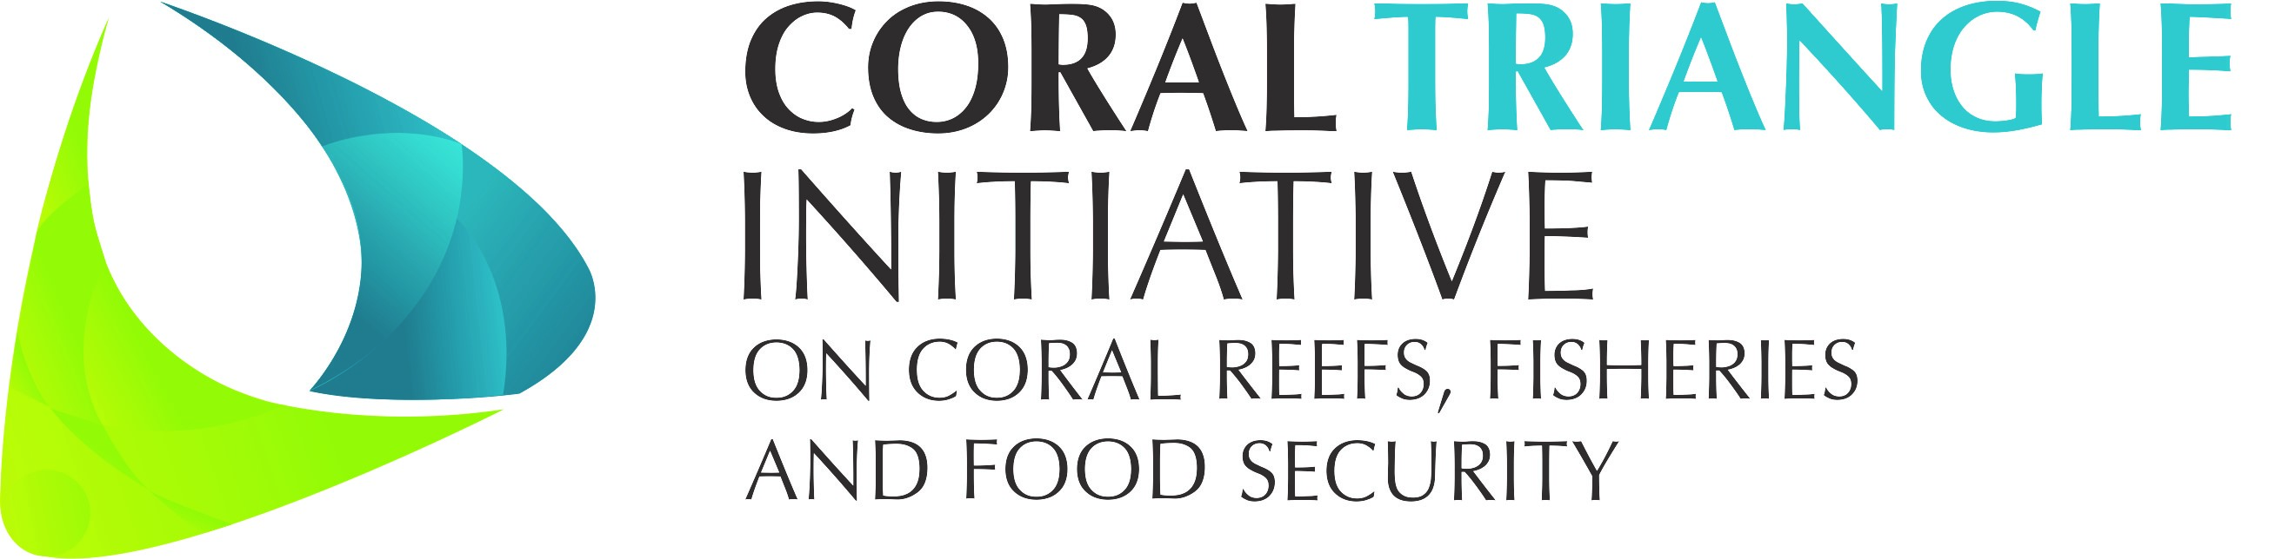

DRAFT Decision Document on

Session 10

Women Leaders Forum (WLF)
___________________

The 13th CTI-CFF SENIOR OFFICIALS’ MEETING (SOM-13)

29 – 30 November 2017
Dusit Thani Manila Hotel
Makati City, Philippines

Adopted on 29 - 30 November 2017
by
the Governments of Indonesia, Malaysia, Papua New Guinea,
the Philippines, Solomon Islands, and Timor-Leste

I. Background

Since the CTI-CFF Women Leaders’ Forum was launched and endorsed by the CTI-CSO in Special SOM (in May 2015), it has been the recipient of many encouraging supports from NCCs and especially from CTI Development Partners. They include, USAID-RDMA, USDOI, CTC, and other partners such as ADB, TNC, WWF and CI.
The past SOM-12 decision includes the continued involvement and participation at local, national regional and international for a to leverage impact.

Throughout 2016/2017; several activities / events have been undertaken and are still in progress. There are:

- WLF Malaysia Meeting; 7th November 2016
- WLF in ADB 50th Annual Meeting; Yokohama, Japan; 7 May 2017
- WLF – CTC Intergenerational Learning Program (2017 – 2019)
- WLF in USAID Oceans Partnership (2017 – 2018)

However, several activities recommended in SOM-11 were not able to be implemented. These include:
- Included/Incorporated gender measures into the CTI M&E Operations Manual. The indicators will be prepared by the WLF Secretariat in collaboration with the WLF focal points and submitted at the next CTI M&E Working Group Meeting;
- Encouraged all CTI-CFF Technical Working Groups to engage and utilize the pool of women leaders in the CI-CFF Member States trained under WLF’s various capacity building activities as resource persons or participants in their respective workshops;
- Encouraged CTI-CFF member countries to link with ministries women empowerment in CTI-CFF WLF activities (this was earlier placed under planned activities); and

II. Decision

Referring to the discussion and consideration among the SOM-13 in session ten (10) in relation to the Cross Cutting Themes on Women Leaders Forum (WLF), the Senior Officials hereby:

- Acknowledged WLF activities throughout 2017;
- Acknowledged and agreed to populate the WLF members directory;
- Acknowledged and agreed to provide full cooperation and participation in existing Partners & collaborators programs;
- Agreed to explore potential cooperation with other organizations with the support from Regional Secretariat;
- Urged the Regional Secretariat to ensure gender measures are incorporated in the Regional Plan of Action (RPOA) review process;
- Urged Regional Secretariat to ensure gender measures are taken into consideration into the CTI M&E Operations Manual. The indicators will be prepared by the WLF Secretariat in collaboration with the WLF focal points and submitted at the next CTI M&E Working Group Meeting; and
- Agreed to continue representing CTI-CFF in regional and international events.

Annexes:
- WLF presentation
- WLF members directory

