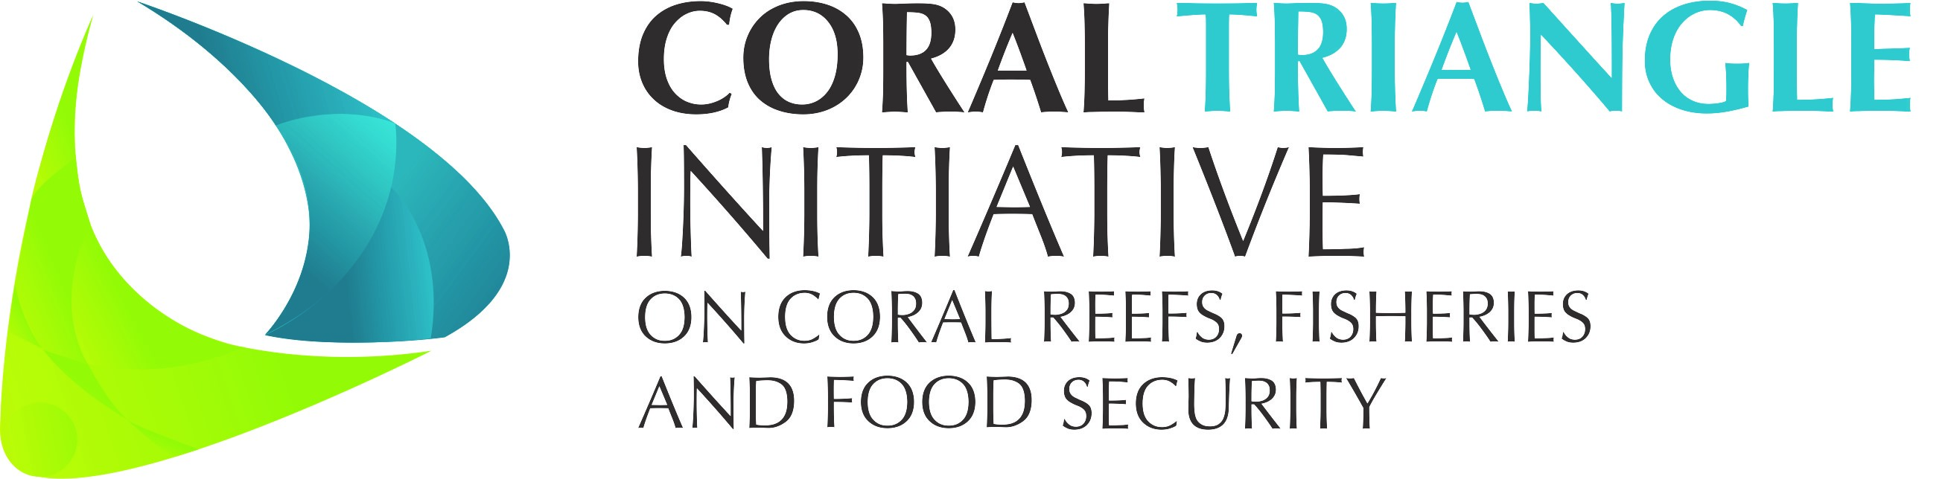

DRAFT Decision Document on

Session 9

Monitoring and Evaluation Working Group (MEWG)
___________________

The 13th CTI-CFF SENIOR OFFICIALS’ MEETING (SOM-13)

29 – 30 November 2017
Dusit Thani Manila Hotel
Makati City, Philippines

Adopted on 29 - 30 November 2017
by
the Governments of Indonesia, Malaysia, Papua New Guinea,
the Philippines, Solomon Islands, and Timor-Leste

I. Background

The Monitoring and Evaluation Working Group (MEWG) received the following decisions from the last 12th Senior Officials’ Meeting (SOM-12):

11.3.1. Acknowledged the progress and adopt the proposed work plan towards the continued operation of the CT Atlas with support from the Regional Secretariat and recognize the urgency for sustainable financial resources for the operation of the CT Atlas;
11.3.2. Urged the Technical Working Groups on Goal 1 “Priority Seascapes” Designated and Effectively Managed and Goal 5 “Threatened Species Status Improving” to finalize its indicators prior to SOM-13;
11.3.3. Encouraged the Regional Secretariat to ensure that the Monitoring and Evaluation System is implemented and guided by the M&E System Operation Manual;
11.3.4. Tasked the Regional Secretariat to allocate budget for the hiring of an M&E Coordinator and agree that the M&E Coordinator, under guidance of MEWG, will develop a transition plan by SOM-13 on the eventual transfer of mandate from MEWG to the Regional Secretariat; and
11.3.5. Tasked the Regional Secretariat to ensure that the MOUs between WorldFish and CT6 Member Countries data sharing are signed by SOM-13.
CT Atlas
Unfortunately, due to insufficient funds the CT Atlas could not be revitalised other than for Marine Protected Areas (MPA) data that were deposited voluntarily by various users. For the same reason, the M&E System Operation Manual could not be implemented as the M&E Coordinator could not be employed as it was not feasible to contract such position in the absence of a working M&E platform.

Several MOUs between WorldFish and CT6 members have expired and several member countries have not signed the MOUs to start with. WorldFish advised the Regional Secretariat that if the same were to be pursued, a Data Sharing Agreement should be pursued instead.

WorldFish submitted an approximate cost to further the work and add value to the current CT Atlas. The proposed work is to be implemented in stages:

- Full Proposal Development to seek financial support (2 months) – USD6,000.00
- Short term plan to redesign CT Atlas (9 months) – USD160,000.00
- Medium term plan to update and expand CT Atlas (15 months) – USD240,000.00
- Long term plan (ongoing)

Review of Regional Plan of Action (RPOA)

A Partners Meeting was convened 23-24 May 2017 in Manila, Philippines in response to SOM-12 call for more transparency and communication between Partners and the Regional Secretariat.

One of the main agenda in the Partners Meeting was the offer of support from the Government of Australia to review the CTI-CFF Regional Plan of Action which is due to expire in 2020. The meeting recommended:

- That the review have an evaluative emphasis and focus, as first flagged at SOM-12;
- That the scope include the effectiveness of the current RPOA as a mechanism – its performance as a means of driving and guiding a multilateral effort, with benefits at regional and national levels;
- That the review be independent, that is, contracted through a competitive process to an evaluation specialist ideally with expertise in evaluating multilateral fora, familiar with the policy, programmatic, financial and administrative instruments used to advance multilateral agendas, and with experience in the Coral Triangle region;
- That the essential oversight process for the review be provided by a temporary Technical Advisory Group (TAG) to be comprised of representatives or Members from the National Coordinating Committees, the Regional Secretariat, and two Partners (NGO, donor). The TAG would develop the Terms of Reference for the evaluation, be part of the selection process for the consultancy, review the consultant's report, and make recommendations to SOM-13;
- That this review be considered as a key input to the process of renewal of the RPOA, scheduled to be completed by end of 2020; and
- That this review be implemented as soon as possible with draft findings ready for presentation to SOM-13.
A letter of support was sent to the Chair of the Committee of Senior Officials (CTI-CSO); Atty. Jonas R. Leones on 29 June 2017 to seek guidance and initiate the review process.

In response, the Chair of CSO has responded via a draft of Terms of Reference for the Consultancy and the formation of the Technical Advisory Group (TAG) to be chaired by the Chair of MEWG.

The draft TORs shall be deliberated prior to SOM-13 for endorsement and initiate this process.

II. Decision

Referring to the discussion and consideration among the SOM-13 on session OF Monitoring and Evaluation Working Group (MEWG), the Senior Officials hereby:

- Acknowledged the situation that CT Atlas is in and adopt workplan towards the continued operation of the CT Atlas with support from the Regional Secretariat and recognize the urgency for sustainable financial resources for the operation of the CT Atlas;
- Urged the Technical Working Groups on Goal 1 “Priority Seascapes” Designated and Effectively Managed and Goal 5 “Threatened Species Status Improving” to finalize its indicators prior to SOM-13;
- Encouraged the Regional Secretariat to ensure that the Monitoring and Evaluation System is implemented and guided by the M&E System Operation Manual;
- Tasked the Regional Secretariat to allocate budget for the hiring of an M&E Coordinator and agree that the M&E Coordinator, under guidance of MEWG, will develop a transition plan by SOM-13 on the eventual transfer of mandate from MEWG to the Regional Secretariat;
- Agreed and endorsed the Terms of Reference (ToR) for Consultancy to Review the CTI-CFF Regional Plan of Action (RPOA) which includes the duration and cost of the consultancy; and
- Agreed and endorsed the Terms of Reference (ToR) for the establishment of the Technical Advisory Group (TAG) to evaluate consultancy proposals; be part of the selection process; review consultancy reports and make recommendations.
Annexes

- MEWG presentation
- Terms of Reference for Consultancy
- Terms of Reference for the formation of the Technical Advisory Group (TAG)

