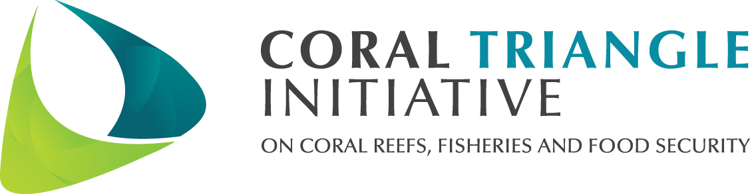

Course on Climate Change Adaptation for Coastal Communities and
Training of Trainers Course
Jan 31-Feb 9, 2012
Philippines

Summary Description

The Coral Triangle Initiative for Coral Reefs, Fisheries and Food Security (CTI-CFF)’s Regional Plan of Action (RPOA) was launched in May 2009 by the six Coral Triangles countries (Indonesia, Malaysia, Papua New Guinea, Philippines, Solomon Islands and Timor-Leste). The RPOA’s Goal 4 encourages local government and communities to understand, assess and take action on coastal issues related to climate change. To catalyze regional sharing of knowledge, methods and strategies related to coastal adaptation, the US CTI Support Program in coordination with the CTI Regional Secretariat and the CTI CCA Technical Working Group is supporting the Philippines and Malaysia CTI National Coordinating Committees in the development, delivery and transfer of a short-course in Coastal Adaptation Planning for Philippine and Malaysian teams.

This is the second of the two-batch CCA training course developed based upon a similar course that fourteen CT6 representatives attended last year at the Coastal Resources Center at the University of Rhode Island (CRC). The University of the Philippines Marine Science Institute, the hub of CCA Learning Network will be the lead trainer with support from CRC and the US CTI Support Program Partners. UP-MSI will be working with appropriate institutional leaders in each Coral Triangle country to ensure designated organizations receive the full course curriculum and the skills to modify the course to suit their national contexts.

Objectives
At the conclusion of both the Climate Change Adaptation Course for Coastal Communities (8 days) and the Training of Trainers course (2 days), the desired results are:

- National government, local government, and assisting organization teams strengthened to:
- Identify climate change risks and assess adaptation options for critical coastal infrastructure, habitats and vulnerable segments of society (i.e. livelihoods/gender) with links to marine protected area and coastal fisheries management.
- Lead an integrated local early action planning process for CCA (organize a team, conduct a qualitative vulnerability assessment, and use the results for early action planning) and manage CCA programs at the national and sub-national levels
- Plan developed to conduct a local vulnerability assessment and identify early actions for CCA in one or two priority/demo sites, with a core team and resource needs identified for Malaysia and the Philippines for immediate implementation
- National resource team (univ, experts, links with other organizations, NGOs) strengthened to support the national and local actions as the country teams move toward implementation and replication of the curriculum, adaption planning and implementation actions.
- Core team of national managers and resource persons from the Malaysia and Philippines strengthened to contribute to regional CTI capacity and future replication and sharing.

Participants
Each country team should include mid-level professionals from national and sub-national government, academia and NGOs who play an advisory, technical support or program design role for planning process and implementation activities in coastal areas. Each country team should include members from across multiple sectors to foster integrated planning mechanisms, specifically natural resources, disaster and local community planning programs. Each country will identify specific geographic locations (preferably CTSP-supported areas) from which to build their site team(s) around.
This course will be tailored to the needs of participants in the Philippines and Malaysia. All participants will attend the eight-day Climate Change Adaptation for Coastal Communities Course, with a few participants from each country team remaining for the ToT to follow. Owing to the fact that the Philippines has three CTSP sites compared to Malaysia which only has one, the organizing team has recommended that the Philippines may send as much as 14 and Malaysia can send as many as 10 participants which will be composed of:
- National level land-use, coastal resources or disaster planning agencies responsible for implementing the CCA targets of their CTI National Plan of Action related to critical coastal infrastructure, habitats and vulnerable segments of society (i.e. livelihoods/gender) in an integrated coastal management context.
- Provincial government, national or local NGO or other stakeholder responsible for critical coastal infrastructure, habitats and vulnerable segments of society (i.e. livelihoods/gender) involved in integrated coastal management from a CTSP-supported geography.
- Participants who are training specialists that will assist in supporting relevant organizations in future delivery of course content. These experts could be extension agents who want to specialize in training delivery. They may be from government, academia or NGOs already active in the priority areas.
- 1-2 CTSP country representatives working with the site team(s) (nominated in agreement with the NCC but should be self-funded)

Given the criteria and the ceiling of the number of participants, the composition of country teams may be broken down into the following:

Composition of Participants | Malaysia | Philippines
Participants from priority geographies inclusive of CTSP representative (local level) | 4  (1 CTSP site) | 10  (3 CTSP sites)
Non-CTSP field site (local level) | 2
National level team | 4 | 4
Total 8-day Course participants | 10 | 14
Note: The ToT participants are required to complete the 8-day course and stay for additional 2 days to attend the ToT. Malaysia and the Philippines are allocated as much as 5 and 7 participants respectively to further attend the 2-day ToT. The NCC is enjoined to identity the ToT participants preferably from national training agencies or academies who may have the mandate to conduct and replicate the training across each country to help implement relevant aspects respective NPOAs as appropriate.

Logistics
The UP MSI in collaboration with the Department of Environment and Natural Resources (DENR) and the US CTI Support Program Integrator will coordinate and provide overall support of this event. For more information about this training, contact Miledel Christine Quibilan (+632-4336063), magsquibilan@yahoo.com; Lynette Laroya (+63927-2679598), lynette_laroya@yahoo.com; Leilani Gallardo (+662-637-8517) lgallardo@uscti.org and/or William Jatulan (+63917-3217592) wjatulan@uscti.org.

Tentative Program for the Courses

Jan 30 - Arrival
Days 1-2 - Basic concepts, climate projections and planning process
Day 3-5 - Vulnerability Assessment Tools and Field Exercises
Day 6 - Data Processing
Day 7 - Adaptation Options
Day 8 - Mainstreaming in Site/Country’s Planning Framework
Days 9-10 - Training of Trainers (Departure for CCA course participants)
Feb 10 - Departure (for TOT participants)

