FINANCIAL STRATEGY FOR
REGIONAL PLAN OF ACTION 2.0

CONTENTS
- INTRODUCTION AND PURPOSE 3
- STRATEGIC GOALS 3
- GUIDING PRINCIPLES 4
- GENERAL APPROACH 4
- Context
- Elements
- Business Planning
- RESOURCES 7
- CTI-CFF member countries contribution
- Partners
- Regional Conservation Trust Fund
- MONITORING AND EVALUATION 8

- INTRODUCTION

The financial strategy for the Regional Plan of Action (RPOA2.0) is guided by the report and studies conducted by CTI Strategic Partners; review of the CTI-CFF RPOA 1.0 gathered through desktop research, interview and FGDs; insights from FRWG meetings and a two-day workshop on Financial Resource Strategy for RPOA 2.0 in 2019. Based on the information gathered from these various sources, it duly notes ‘the importance of the enabling conditions set by the political and administrative leadership in the CT countries is highly relevant when considering options to mobilize financial resources for the goal of the CTI-CFF. Building on the important achievements of the RPOA 1.0, particularly the frameworks established for the CTMPAs, EAFM, and referring to the conclusion in the series of CT6 meetings, the the blue economy and blue growth will be the way forward to gain and retain financial support from in and outside of the CTI region for the RPOA priorities. Regional collaboration through the RPOA has shown to be successful when capacity development is considered and the high value of the CTI resources also continue to provide a high potential for the development of a trust fund seeded from a diverse and innovative number of finance solutions as long as the institution is proven to be effective, governance is strong and the value proposition of the CTI-CFF is clear.

This financial strategy is intended to serve as a guide to accelerate financing of projects that will help further manage and protect the marine and coastal ecosystems within the Coral Triangle region. The financial strategy for RPOA 2.0 will also build on the partnership established with CTI Partners through the years to support projects based on shared goals and vision for the region. It will be used to ensure and promote sustainable financial mechanisms within CTI-CFF to carry out the activities identified in RPOA 2.0.

II. STRATEGIC GOALS

The overall goal is to develop and execute financial strategies, and other innovative financing mechanisms to increase financial self-reliance and ensure financial sustainability of CTI-CFF towards the attainment of the goals of RPOA 2.0. Specifically, the financial strategy aims to:

- Bring together CTI-CFF Member Countries and diverse sectors to identify and implement regional development and investment priorities in a coherent manner to optimise available resources.
- Increase access to financial resources to support the conservation and management of ecosystems, improve food security, sustainable fisheries and coastal livelihood of the CTI-CFF member countries

- Strengthen partnerships and cooperation with funding institutions, donor agencies, and international non-government organizations to support innovative and sustainable projects at the regional and national levels

III. GUIDING PRINCIPLES

To ensure the sustainable flow of the funding needed to accomplish goals and targets of RPOA 2.0, the following components shall form part of all the programs, projects, and activities to be undertaken:
- Prepared, documented, and budgeted
- Presented to and negotiated with, appropriate sources of funding and approval by the CT6 Member Countries during official meetings (SOM 17th and MM-8th) at CTI-CFF
- Monitored and accounted for transparency to all stakeholders.

All these components must all work together in a coordinated and systematic manner.

IV. GENERAL APPROACH

A. Context

The implementation of the RPOA 2.0 will be complex, encompassing:
- Actions by national governments.
Wide-ranging and inclusive actions by CTI-CFF Member Countries organized around over 2 goals, 3 objectives, 7 targets, 17 regional activities, 33 outcomes, 89 outputs, 213 indicators and national actions in each country.

- Actions by other key stakeholders.
Wide-ranging and inclusive actions by (ID, MY, PH, TL) concerned government agencies in the areas of marine, fisheries, environment, science and technology and universities. Further it will actions from local communities, non-governmental organizations, and private sector actors as well as profits and non-profit organizations.

- Projects and funding programs.
Implementation of mutually agreed upon projects and funding programs over the 10-year timeframe of the Plan of Action.

- External funding support.
Funding support from CTI Partners and other external funding institutions investing in the Plan of Action, is likely to be significant in size.

B. Elements of general approach to financial resources
Given the wide-ranging and highly complex context of the RPOA 2.0, a strong collaboration and a systematic approach to financial resource issues shall be carried out. At the broadest level, this will entail collaboration around two activities: (i) mobilization of funding; and (ii) enhanced “financial architecture” needed to structure and coordinate funding flows to effectively support priority activities and programs. Our general approach to collaboration in this area will cover the four major elements outlined below:
Element 1: Engagement with external funding institutions {ID, MY, PH, TL: ok with element 1)
- Promote engagement with funding institutions. CTI-CFF will continue and actively advance and strengthen engagement with a wide range of external funding institutions, donor, philanthropits, and private sector groups.

- Strengthened and institutionalized donor coordination process. CTI-CFF through the Regional Secretariat shall ensure a transparent and systematic coordination process with donors to maintain trust and credibility and ensure smooth and timely fund flow. CTI-CFF shall maintain regular and/or promote regular dialogue or communication on key issues related to funding mobilization, funding coordination, and financial architecture with donors partners.

- CTI-CFF/Country-driven program, projects and activities funded by donors. CTI-CFF shall ensure that donor funding programs are structured to meet the needs of CT countries in the context of implementing the Regional and National Plans of Action.

Element 2: Information and assessments
(Note : Indicator shown in the separate table)
- Assess “big picture” funding needs, gaps and options. Early in the implementation phase, CTI-CFF will prepare general estimates for total funding (and funding gaps) covering the entire RPOA 2.0, followed by more in-depth refinement of estimates over time. This will be combined with feasibility assessments of various funding options.

- Assess finer-scale funding needs, gaps and options. CTI-CFF would conduct finer-scale financial assessments of needs and gaps -- along with feasibility assessments of various funding options. These finer-scale assessments will be performed (i) at scales that are relevant to specific commitments in the Plan of Action (e.g., site, seascape, national); and (ii) on specific themes emphasized in the Plan of Action (e.g. marine protected area networks, ecosystem approach to fisheries [PH, TL, ID,MY] management). Such finer-scale assessments may require development of detailed “business plans”.

- Assess and manage information on funding. CTI-CFF would strengthen its information management systems that will help to manage and track information on funding programs and funding flows for transparency and accountability.

Element 3: Mobilization of funding [ID, MY, PH TL: agree with the revisions]
- Link funding directly to CTI [PH: Regional Plan of Action (RPOA) 2.0]. CTI-CFF’s collaborative efforts to mobilize funding will be organized around and linked directly to RPOA 2.0, with specific funding programs created to achieve its goals and objectives.

- Mobilize total funding needed. CTI-CFF shall take the necessary steps to mobilize the level of funding needed to achieve the goals and objectives in the CTI RPOA 2.0.
CTI-CFF has set in place a mechanism to ensure transparent, smooth, and timely coordination for donor/partner support as shows in Project Preparation Flowchart Figure 1.
- Emphasize contributions and alignment with agreed global, CTI-CFF regional goals, objectives and regional activities. CTI-CFF assesses and communicates the contributions of marine and coastal resources to contribute to the achievement of global and regional goals and objectives, and to be discussed with external funders.

- Mobilize domestic and international funding. CTI-CFF in coordination with its NCCs shall mobilize large-scale domestic and international funding.

- Achieve a solid diversification of funding sources. CTI-CFF shall actively mobilize funding through a diverse array of sources, including national budget allocations, trust funds, tourism based fees, blue bonds, grants and loans by international funding institutions, and private sector sources.

- Promote sustainable funding. CTI-CFF [ID: may want to] shall put in place sustainable finance mechanisms designed to provide a significant portion of the reliable, long-term funding needed (e.g. trust funds, tourism fees, fishery license fees).

- Joint efforts to mobilize external funding. CTI-CFF shall undertake joint efforts to mobilize support by external funding institutions for those targets in the RPOA 2.0 where such joint efforts are needed.

Element 4: Financial Ecosystem - financial mechanisms and fund distribution
The CTI Financial Ecosystem has three main level of participants:
- Donors
- Intermediaries
- Implementers
CTI financial ecosystem describes the international funders followed by intermediaries, nationals, and local entities which implement the activities at in-site level.
The discussions between CTI-CFF Regional Consevation Trust fund Technical Committee faciliated by Wildlife Conservation Society (WCS) and Conservation Finance Alliance (CFA) and the Regional Secretariat emphasize the issue of financing the activities through trust fund mechanism as stated in RPOA 2.0. [ID, MY, PH, TL] CTI-CFF emphasized the need for financing the activities through trust fund mechanism as stated in RPOA 2.0. This trust fund mechanism includes donors from various sectors whereas intermediaries in this case is to bridge the donors and CTI-CFF. Implementers are at the national levels/NCCs. The main role of the Trust Fund is to facilitate and to coordinate the flow of trust fund from donors, intermediaries and implementers.]
At the national level, [ID, MY, PH, TL] CTI-CFF appreciates the model of the Caribean Conservation Initiatives/CCI, Carribean Biodiversity Fund as reference for the financial strategy through trust fund. At the national level, each NCC must set up its own national trust fund.
C. Business Planning
Between 2020-2023 a feasibility assessment of innovative sustainable financial measures is prepared and distributed, building on existing initiatives, programs and studies, to aid CT6 members and partners. (RPOA 2.0 output A1.2.1.a).
This financial strategy support the activities as :
- Support and/or strengthen regional and national conservation and management actions of coastal and marine ecosystems (coral reefs, mangroves, and seagrass beds) in the Priority Seascapes and CTMPAS through strategic partnerships (RPOA 2.0 activity A1.1)
- Develop and execute sustainable finance strategies, and other innovative financing models, to increase financial self-reliance, for the management of the coastal and marine ecosystems in Priority Seascapes and CTMPAS (RPOA 2.0 activity A1.2)
- Mainstream Ecosystem based adaptation and mitigation approaches for CT6 members and partners under the CTI-CFF framework (RPOA 2.0 activity A1.3)

- Develop and implement strategies and initiatives for addressing waste management and marine pollution in the Coral Triangle region (RPOA 2.0 activity A2.1)

- Implement the COASTFISH regional framework for sustainable coastal fisheries and poverty reduction initiatives in achieving food security and improving coastal livelihoods (RPOA 2.0 activity B1.1)
V. RESOURCES
- CTI-CFF Member Countries Contributions
[To maximize the annual contribution of CTI-CFF member countries, commitment and support from government leaders need to be strategically formulated. Country contribution need to be continued at the minimum level to support administrative/operations of the Regional Secretariat.] [ID, MY, PH, TL: To point out the importance of sustainable annual contribution of CTI-CFF member countries as reflection of their commitment and support to the CTI cause.]

- Partners
The support and cooperation from CTI Partners have helped realize and attain the goals of CTI-CFF through the years. They will play a significant role in carrying out the programs, projects, and activities of CTI-CFF. Partners/Donors may be:
- Multilateral Donors
- Bilateral Donors
- Private Donors
CTI-CFF has set in place a mechanism to ensure transparent, smooth, and timely coordination for donor/partner support as shown in the illustration below:
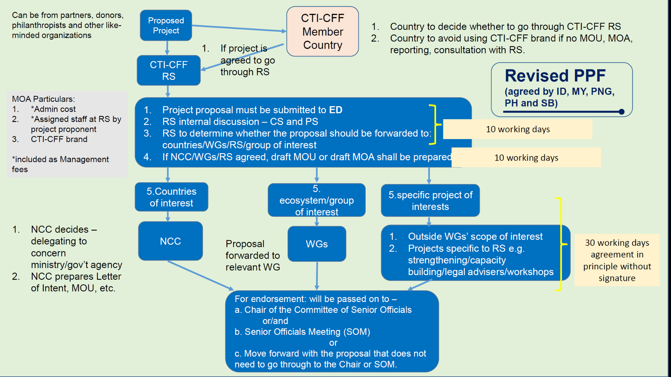
Figure 1. Project Preparation Flowchart [TL : no comment on the flowchart]

- Regional Conservation Trust Fund
Considering that the CT6 country membership is the most “sustainable” source of funding for the CTI-CFF at the moment, it is important to consider that the fees combined are not sufficient to support more than the basic operations of the CTI-CFF and some programs. Therefore, a dedicated regional umbrella funding mechanism to support activities is a key part of the financial architecture. The Regional Conservation Trust Fund as a mechanism to capture finance mobilized from various solutions, would be a good option to consider for the financial needs related to implementing priority regional actions from the RPOA 2.0 and priority national level actions from the NPOAs that align most directly to the goals of the CTI-CFF.

VI. Monitoring and Evaluation
All the indicators related to long-term and diverse finance mechanisms would be considered in the M&E plan framework and the progress will be tracked for those indicators. The regular financial monitoring is an integral part in monitoring the projects, focusing on any changes in the context that may have significant implications for the financial strategy and implementation of the activities. Operations and Technical staff would provide key information related to finance to the Senior Managements during team meetings to help them analyze and make strategic decisions accordingly.
Accountability would be a key component for CTI-CFF to collaborate and communicate with the CT6 countries as well as NCC, TWG, MEWG and Regional Secretariat, which intend to support.
- By 2030, at least 3 new significant and strategic regional/international partnerships and at least 2 new partnerships are implemented in each of the CT countries with clear and measurable goals for improving the status of coastal and marine ecosystems (coral reefs, mangroves, and seagrass beds) in the Priority Seascapes and CTMPAS (Output A1.1.1.b)
Output Indicator:
increase amount of funding from Partners as a proportion of Program Services budget, by 2030.

- By 2023 at least 2 innovative financial options are initiated by the RS with CT6 countries and partners, building on existing initiatives where appropriate (Output A1.2.1.b)
Output Indicator:
- # Of innovative financial options are initiated by the RS with CT6 countries and partners, building on existing initiatives where appropriate, by 2023
- Amount of funding received for innovative financial options, initiated by the RS with CT6 countries and partners, building on existing initiatives where appropriate, by 2023.

- By 2028, at least 4 innovative financial options are fully operational within the CT Region (Output A1.2.1.c)
Output Indicator:
- # Of innovative financial options are fully operational within the CT Region, by 2028
- Amount of funding received for the innovative financial options, which are fully operational within the CT Region, by 2028

- By 2030, at least 10% of the management costs of the Coral Triangle Marine Protected Areas (CT-MPAs) of level 3 and 4 of CTMPAS are, in general, sustainably supported by innovative and sustainable financing options.
Output Indicator:
Amount of the management costs of the Coral Triangle Marine Protected Areas (CT-MPAs) of level 3 and 4 of CTMPAS are, in general, sustainably supported by innovative and sustainable financing options, by 2030

- Regional ecosystem-based adaptation and mitigation initiatives are actively pursued and promoted to improve protection of key coastal and marine ecosystems in the Coral Triangle region (Outcome A1.3.1)
Output Indicator:
Amount of funding allocated for regional ecosystem-based adaptation and mitigation initiatives to improve protection of key coastal and marine ecosystems in the Coral Triangle region

- By 2030, at least 10 regional/national projects and joint collaborations including regional campaigns are established and implemented (e.g., marine waste management by Maritime Local Government Networks/LGN)
Output Indicator:
- # Of regional/national projects and joint collaborations are established and implemented on marine pollution (e.g. marine waste management by maritime Local Government Network), by 2030.
- Amount of funding committed by CT6 member countries and partners for regional/national projects and joint collaborations including regional campaigns, by 2030

- By 2025, at least 2 collaborations/partnerships are mobilized to support the implementation of COASTFISH regional framework at both regional and national levels (Output B1.1.1.b)
Output Indicator:
Amount of resources committed by CT6 member countries and partners to support the implementation of COASTFISH regional framework at both regional and national levels, by 2025

- By 2030, the levels of adaptive capacity of CT6 coastal communities and local governments are strengthened through increased awareness/education/training on climate change impacts, implementation of community-resilient and adaptation programs and provision of climate-financing support
Output Indicator:
Amount of climate-financing/ investments for coastal communities by the partners to strengthen levels of adaptive capacity of CT6 coastal communities and local governments, by 2030

Workshop Report CTI-CFF Financial Resource Strategy, PT. Hatfield Indonesia, 2019
Towards a Comprehensive Financial Architecture for the Coral Triangle Initiative, 30 March 2015

