Progress Report
^{January –OCTOBER 2019}
CTI-CFF Regional Secretariat
2019

TABLE OF CONTENTS

Introduction……………………………………………………………………….3

Technical Working Groups

Seascapes Working Group……………………………………………………….

Ecosystem Approach to Fisheries Management (EAFM) Working Group……..
Marine Protected Area (MPA) Working Group…………………………………
Climate Change Adaptation (CCA) Working Group……………………………
Threatened Species (TS) Working Group………………………………………

- Governance Working Group
Financial Resources Working Group……………………………………………
Internal Resource Committee……………………………………………………
Monitoring and Evaluation Working Group……………………………………

- Cross-Cutting Initiatives
Local Government Network…………………………………………………….
Women Leaders Forum………………………………………………………….

Capacity Building Program for Regional Coral Triangle Network Officers (RCTNO)

- Partnerships and Potential Regional Programs………………………………..

- Corporate and Financial Management Activities……………………………..

Communication and Outreach Activities………………………………..……..

Upcoming activities for November to December 2019 Activities……………..

MESSAGE

This 2019 Progress Report highlights the various activities of the CTI-CFF through the Regional Secretariat which had been undertaken, supported, and participated in as our continuing commitment to provide the enabling environment for better articulation and coordination among ocean, marine and coastal sustainable advocates as it serves its role as custodian of the global marine biodiversity. This progress report covers the period from January to October 2019.

We have been persistently working together with the CT6 Member Parties as well as our Development Partners and other stakeholders to be able to achieve the mission and goals set in the Regional Plan of Action.

Particularly, this year, the CTI-CFF Regional Secretariat focused on the development of the Renewal of the CTI-CFF Regional Plan of Action or RPOA 2.0 through a series of consultative workshops, meetings as well as online questionnaires. We thank all the National CTI-CFF Coordinating Committees (NCCs) and Development Partners as well as the staff of the Regional Secretariat for their support and cooperation in this process.

This year, the Regional Secretariat also participated in various regional and international activities as a venue to further promote CTI-CFF and its mission as well as align with other international bodies in the promotion and conservation of marine and coastal ecosystems.

At the Regional Secretariat Headquarters, we continue to improve our systems ad operations for better governance of the Regional Secretariat as an international organization. We recognize the value of transparency and accountability. We thank the USAID RDMA for supporting the Regional Secretariat in the improvement of its financial management system through the US Department of Interior.

I also would like to extend my appreciation to the team of the Regional Secretariat for their hard work and commitment to ensure that we are able to smoothly and successfully carry out the activities of the CTI-CFF.

To this end, I would like to assure our partners and stakeholders that the CTI-CFF through the Regional Secretariat will continue to perform an active role towards better facilitation and coordination of CTI-CFF initiatives.

HENDRA YUSRAN SIRY, PhD

Interim Executive Director

CTI-CFF Regional Secretariat

INTRODUCTION
In 2019, the CTI-CFF with cooperation and support from CT6 member countries particularly, the National Coordinating Committees, Working Groups, Development Partners, implemented activities/conferences/workshops that were all aimed to realize the goals of the Regional Plan of Action. Also, this year, the CTI-CFF focused in its efforts in preparing for the renewal of the CTI-CFF Regional Plan of Action (RPOA 2.0) that will serve as a guiding foundation for the CTI-CFF in the next ten years. Series of workshops, consultations, small groups meetings and questionnaire were conducted with various stakeholders to gather a wholistic perspective on the needs, challenges and opportunities facing the Coral Triangle Region today and look how to best position CTI-CFF.

II.TECHNICAL WORKING GROUPS
The five working groups continue to meet, build capacity, exchange insights, and plan activities throughout 2018 to meet the targets identified in each goal.

Seascapes Working Group

i. 6th Seascapes Working Group Meeting
September 3-4, 2019
Hotel Jen, Manila
Philippines

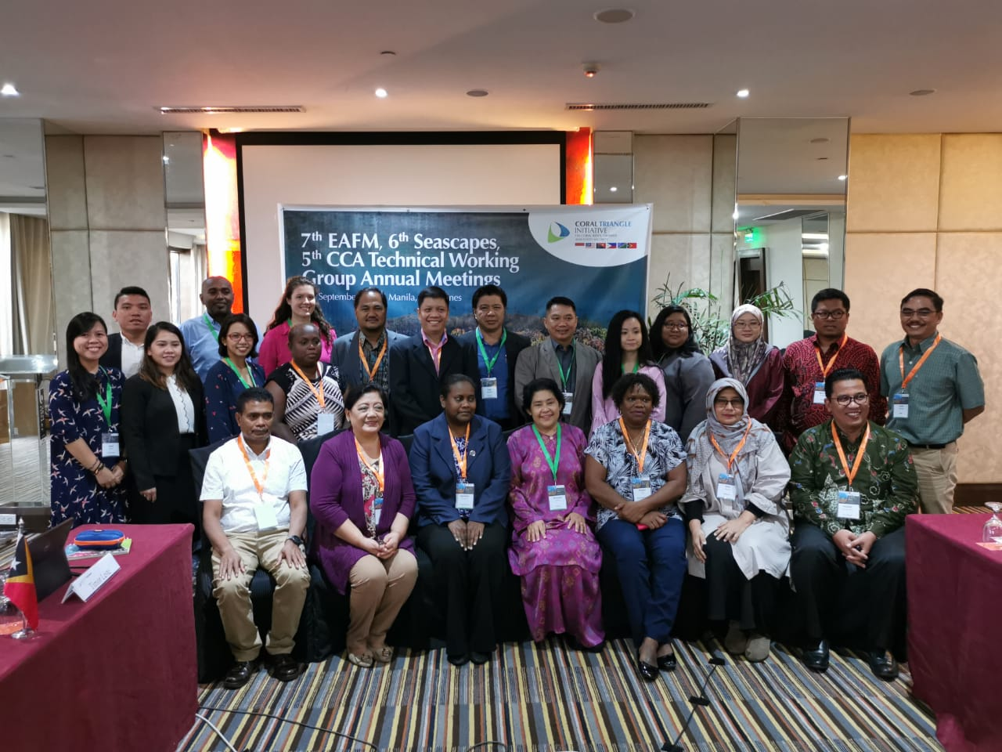
Participants of the 6th Seascapes Technical Working Group Meeting held in Manila, Philippines. Photo credit: CTI-CFF RS/A. Anggorojati

The Annual Seascapes Working Group Meeting was an opportunity to evaluate the accomplishments in the current year based on the approved workplan for 2019 during the 14th SOM as well as plan ahead activities for 2020 taking into considerations the renewed CTI-CFF Regional Plan of Action RPOA 2.0.

Among the notable agreements from the meeting were:
- Recognized that the Seascape has been a successful mechanism as a chosen geographical area under RPOA 1.0. Hence, the need to continue strengthening this Seascape mechanism and push for its inclusion in the RPOA 2.0.;
- Agreed that the Seascape Working Group will submit its position for the inclusion of the Seascape mechanism in the RPOA 2.0 through the Regional Secretariat;
- Agreed that the TOR for each sub-working group will be developed by each sub-working group and that the role of the Regional Secretariat as Coordinator at the regional level highlighting fundraising role is recognized in a later time in the process;
- Agreed in amending some items in the Rules of Procedures of the CTI-CFF Seascape Working Group for 15th Senior Officials Meeting endorsement (as highlighted in Chair’s Summary);
- Encouraged Indonesia, Papua New Guinea and Solomon Islands to continue its discussion on Bismarck-Solomon Sea Ecoregion (BSSE) until the three countries have come up with a solid proposal to be submitted to the GEF 7 and other potential opportunities;
- Encouraged Indonesia and Timor Leste to continue to develop a program on the development of Lesser Sunda Seascape (LSS) despite recognized challenges; and
- Requested the Regional Secretariat to assist in the follow-up of the final approval of Regional Strategic Action Plan (RSAP) to Indonesia, and once approved, for Indonesia, Malaysia and Philippines to meet and discuss the plan with invitation to other CT6 member countries for cross-scale learning

The full Chair’s Summary of the 6th Seascape Technical Working Group Meeting can be accessed at https://bit.ly/2lGUHtJ.

Ecosystem Approach to Fisheries Management (EAFM) Working Group
- Workshop on Catch Documentation Traceability System Design and Development Based on EAFM in Timor-Leste
Dili, Timor-Leste
June 25-26, 2019

Cognizant of these critical issues, the CTI CFF Regional Secretariat partnered with USAID Oceans, US Department of Interior (DOI), National Oceanic and Atmospheric Administration (NOAA) and Southeast Asian Fisheries Development Center (SEAFDEC) conducted a workshop on electronic catch documentation and traceability (eCDT) among marine and fisheries specialists for CT6 member countries. This workshop focused on increasing understanding of eCDT and how it can support ecosystem approach to management of fisheries (EAFM) to ensure sustainable fisheries management.

Particularly, the workshop highlighted the following:
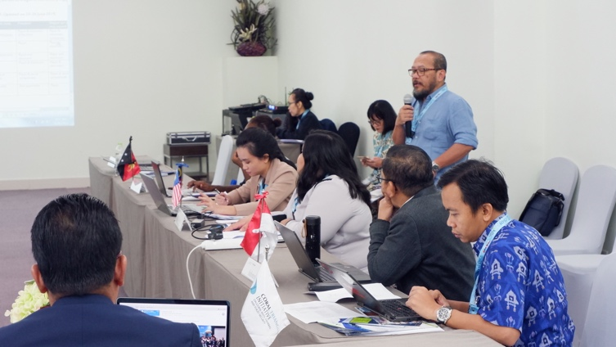
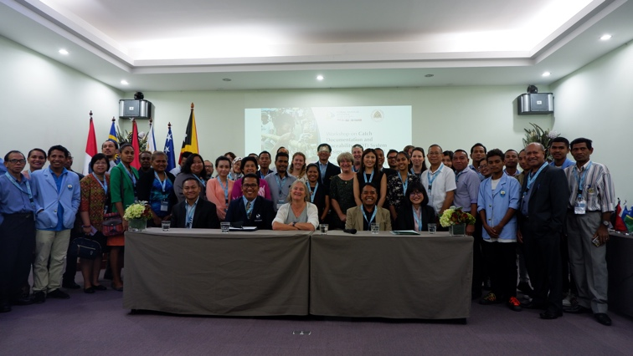
- Acknowledged the importance of CDT technology, taking particular note that eCDT systems should be built upon existing CDT protocols, and supported by strong enforcement among government agencies and presence of a clear business model; and that effective fisheries management plans should incorporate and be backed by eCDT systems along with other management measures;
Participants of the Workshop on CDT Systems in Bali, Indonesia. Photo credit: CTI-CFF RS/J. Polita
- Acknowledged that human welfare and gender considerations are integral to fisheries management and should be included as key data elements in the eCDT programs of the CT6 countries and considered in the RPOA 2.0, and note the effort of USAID Oceans to advocate during its remaining life of project for development partners and other related stakeholders to continue the work that it has started with respect to human welfare and gender;
- Noted that CT6 member countries, except the Philippines, have no experts on CDT, and suggest that USAID Oceans use this gap as an opportunity to support future activities during its remaining life of project;
- Acknowledged that all resources and publications developed by USAID Oceans are public domain, and encourage the CT6 countries to use and adapt these resources and publications according to their respective needs as may be applicable.

The activity was hosted by the Timor-Leste NCC and supported by the USAID Regional Development Mission for Asia (RDMA) through US DOI.

ii. 7th Ecosystem Approach on Fisheries Management (EAFM) Working Group Meeting

Hotel Jen, Manila

Philippines

September 2-3, 2019

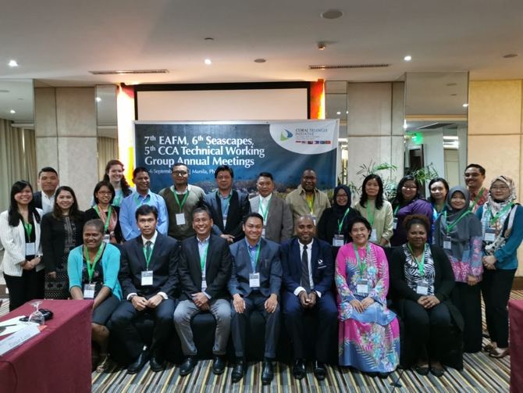
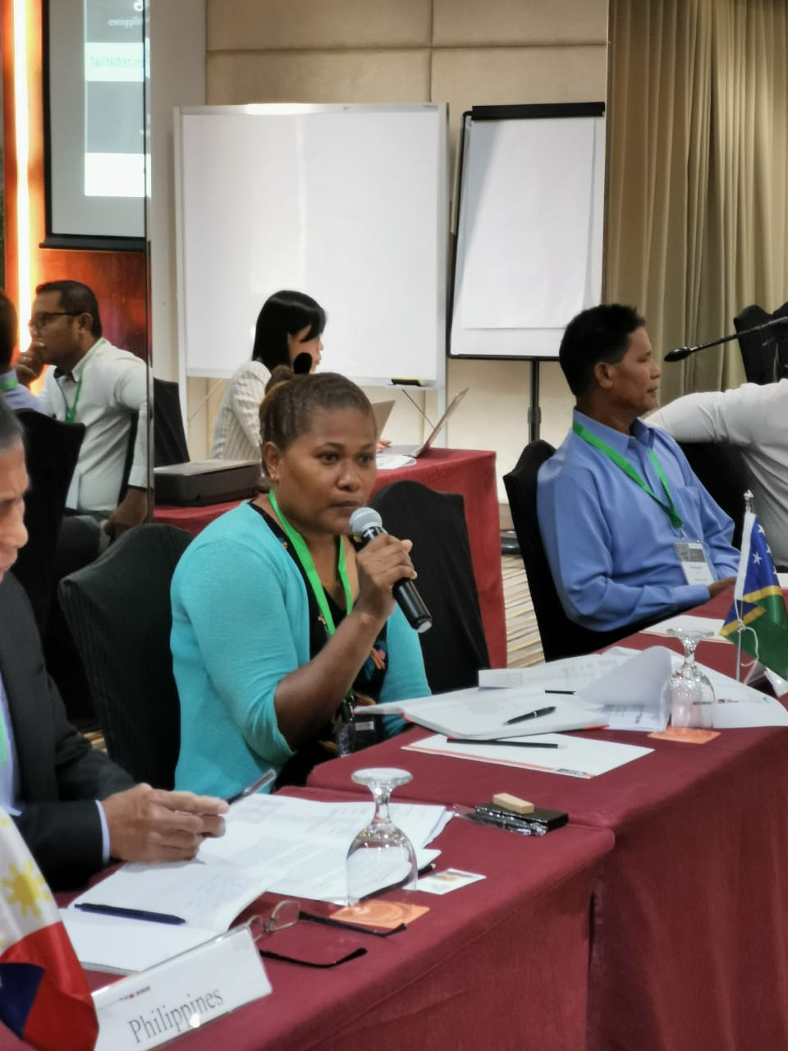
Along with finalization of the Sulu Sulawesi Seascape Sub-Regional EAFM Plan, the 8th CTI-CFF EAFM Working Group Meeting was also a venue to evaluate the implementation of EAFM workplan 2019 as agreed in SOM 14 December 2018 in the Philippines. The Meeting also came up with a draft workplan and budget 2020 towards preparation for Pre-SOM and SOM-15 in Solomon Islands.
Participants of the EAFM TWG Meeting in Manila, Philippines. Photo credit: CTI-CFF RS/A. Anggorojati

Among the agreements in the meeting are:
- Requested the Regional Secretariat to submit the inputs of the EAFM Working Group on the COASTFISH Plan to PT. Hatfield for inclusion in the draft RPOA 2.0 document;
- Requested the Regional Secretariat to write an official letter to USAID RDMA and USAID Oceans regarding request for provision of an e-CDT Technical Guidance document for CTI;
- Requested the Regional Secretariat to circulate the inputs and suggestions from Philippines and Malaysia to the CT6 countries by mid of September 2019;
- Noted the remarks from Indonesia to consult with their national working group regarding the inputs and comments from Malaysia and Philippines and to provide their feedback/response by the end of September 2019;
- Noted the remarks from USAID Oceans regarding approval of the comments and inputs from Malaysia and Philippines and note that the Sub-Regional EAFM Plan in Sulu-Sulawesi Seascape is a document owned by the stakeholders within the Sulu-Sulawesi Seascape;
- Acknowledged and appreciated the potential support of USAID Oceans in partnership with Conservation International - Philippines in the following:
  - Conduct of a regional planning workshop to identify priority activities to be implemented under the Sub-Regional EAFM Plan in Sulu-Sulawesi Seascape;
  - Facilitate the establishment of the Sub-Regional Mechanism for Sulu-Sulawesi Seascape and the development of TOR; and
  - Provide coordination support to promote the engagement of Indonesia, Malaysia, and Philippines in the implementation of Sub-Regional EAFM Plan in Sulu-Sulawesi Seascape and continue support for Seascape and EAFM Working Groups

The full Chair’s Summary of the 7th EAFM Technical Working Group Meeting can be accessed at https://bit.ly/2kus6aZ

Marine Protected Areas Working Group

Workshop for the development of a protocol for the monitoring of marine protected

areas
September 27-October 4, 2019
Gorgona, Colombia

The 5-day workshop was organized and fully supported by the Corredor Marino del Pacifico Este tropical (CMAR). This activity was part of the joint work between CMAR and CTI-CFF to strengthen Regional initiatives aimed at the conservation and sustainable use of marine biodiversity in the Pacific Ocean region.

Participants from the CTI-CFF were:
- Mr. Ikram Malam Sangaji
BKPN, Ministry of Marine Affairs and Fisheries, Kupang East Nusa Tenggara
Indonesia

- Mr. Fazrullah Rizally bin Abdul Razak
Sabah Parks, Kota Kinabau
Malaysia

- Mr. Bernard Komberg Suruman
Conservation Environment and Protection Authority, Port Moresby
Papua New Guinea

- Mr. Peter Fitz Husi’au’ana Kenilorea
Ministry of Fisheries and Marine Resources, Honiara
Solomon Islands

- Mr. Sabino Leto Adonia
Ministry of Agriculture and Fisheries, Dili
Timor-Leste

Participant from Philippines was unable to join due to challenges in securing travel authority

CMAR and CTI-CFF participants both shared experiences on the sustainable management of fisheries, control and surveillance and ecotourism and climate change adaptation.

The CMAR workshop was a follow up of the previous joint activity entitled “Regional Training Workshop on Ecosystem Approach to Fisheries Management (EAFM) in Collaboration with Corredor Marino Del Pacifico Este Tropical (CMAR)” which was conducted in Bali, Indonesia last 7-10 August 2018.

- 8th MPA Regional Exchange and 8th MPA Working Group Meeting
Le Meridian Hotel and Kudat Golf Marina Resort, Kota Kinabalu
Sabah, Malaysia
October 16-20, 2019

The 8th Marine Protected Area (MPA) Regional Exchange and 8th MPA Working Group focused on strengthening the region-wide comprehensive, ecologically representative and well-managed Coral Triangle MPA System (CTMPAS) by conducting a review of its activities and effectiveness management tools.

The event was attended by representatives from CT6 Members Parties (except Philippines) and development partners from WWF Coral Triangle Program and Coral Triangle Center. The Government of Malaysia with support from Sabah Government and Sabah Marine Park hosted the events from 16th-19th October 2019 in Kota Kinabalu and Kudat, Sabah, Malaysia

The MPA Working Group visited the Tun Mustapha Park, a recognized globally significant marine conservation area in Sabah, Malaysia. The park is 898, 762 hectares in size, and located off the districts of Kudat, Kota Marudu and Pitas right up to the Balabac Strait.

The visit was part of the 8th MPA Regional Exchange to share best practices in effectively managing marine protected areas. Also, it was an opportunity to look into the strengths and challenges in the management as well as potentials to further develop the effectiveness of the management of the sites towards sustainable marine eco-tourism.

The MPA Working Group also met to discuss the progress of the SOM-14 decisions as well as plans for 2020. Among the recommendations agreed upon are as follows:
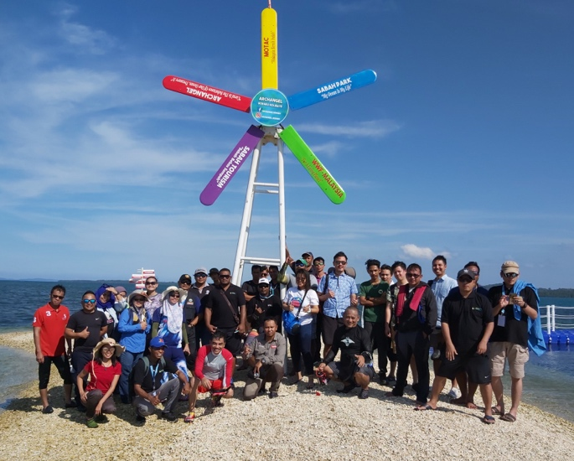
- Tasked Regional Secretariat to provide the Term of Reference (ToR) on Sustainable Marine Tourism Task Force to the MPA TWG with a formal letter requesting to identify the focal points, pilot community site(s) for immediate activities and higher-level site(s) for future planning.
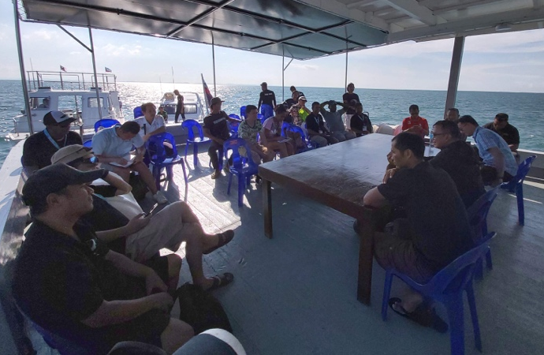
- Recommended NCC to socialize with national counterparts the destination development programs and criteria from the Global Sustainable Tourism Council (GSTC) for potential application in their national pilot sites, and provide brief report to Regional Secretariat.
- Recommended Regional Secretariat and Task Force to provide support in the preparation of a guideline or outline for the concept paper of a joint roadmap of sustainable tourism for five years at prioritized community sites, and phasing into larger sites;
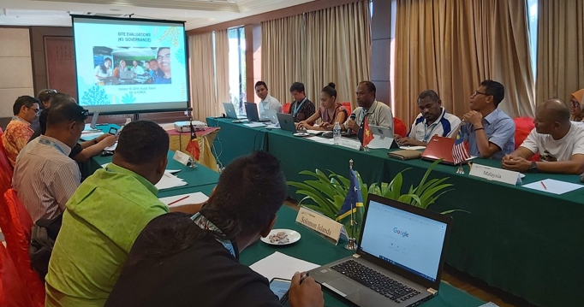
- Recommended all NCCs to work with their working groups to complete their data inputs to the CT Atlas in preparation for the CT Atlas training in the First Quarter of 2020.
- Recommended for the formal certification of Category 1, 2, 3 and 4 be done every two years at SOM
- Recommended NCCs to prioritize the external advisors who will review the CTMPAS Category 3 and 4 sites
Top to bottom: The MPA Working Group visited the Floating Coral Bar, which is part of the Tun Mustapha Park; the MPA Working Group listened to the Kudat Turtle Conservation Society as they explained their efforts in preserving and protecting turtles in Tun Mustapha Park; and the MPA Working Group shared their outputs on assessing the sites in the Tun Mustapha park. Photo credit: CTI-CFF RS/J. Polita
- Requested RS to circulate the list of external advisor candidates along with their brief profile to National MPA focal points, copy furnished NCCs to be finalized in the Pre-SOM 15
- The TWG recommended that the next steps in strengthening the CTMPAS is to:
a. develop pilot activities in community sites in CT6 member countries that integrate with the EAFM COASTFISH program in the priority Seascapes
b. develop awareness and capacity in the CT6 member countries on the use of MPA networks as a tool for designing and integrating Category 3 and 4 MPAs with the prioritized roadmaps from EAFM, Threatened Species and Climate Change Adaptation Technical Working Groups for next operational steps in the priority Seascapes
c. recommend that the MPA Working Group complete the design of CTMPAs award program to first be launched in 2021 at the next SOM in connection with the reverification of the CTMPAS inventory
- Approve the MPA TWG Workplan.

Climate Change Adaptation Working Group
i. Climate Change Adaptation Capacity Building in Coral Triangle Countries: Increasing Resilience and Adaptive Capacity of Coastal and Marine Ecosystem through Technical Communication, Education and Public Awareness (CEPA) Workshop
Aston Marina Hotel, Jakarta, Indonesia
July 2-4, 2019

CTI-CFF’s Climate Change Adaptation Working Group (CCAWG) pushed on raising awareness on climate action for coastal and marine ecosystem conservation and adaptation during its three-day workshop in Jakarta, Indonesia.

CCA WG Chair Noel Gaerlan in a message delivered by Ms. Mary Angelie Sto. Domingo, Executive Assistant of Climate Change Commision (CCC) noted the need to simplify blue carbon in a way that it is easily understood by local communities and local government to be able to gain support and take concrete actions.

The 3-day workshop included a field trip to Untung Jawa Island and a knowledge exchange among CTI country delegates and technical experts to raise climate action for coastal and marine ecosystems conservation and adaptation. The workshop also discussed the importance of developing an effective communication education and public awareness strategy which is crucial for the climate change adaptation strategy.

One of important outputs from the workshop is the Initial Proposed Plan of Action of Climate Change Adaptation 2020 – 2024 which was facilitated by Mr. Safran Yusri (Terangi Foundation), Mr. M. Barmawi (BPSPL Denpasar), Ms. Ade Rachmi Yuliantri (TNC). The recommendations from the workshops will be presented and deliberated at the Annual CCA TWG meeting on September 5-6, 2019 in Manila, Philippines.

The workshop is supported by GIZ-Climate Governance, CTI-CFF Regional Secretariat, Indonesia’s Ministries of Environment and Forestry as well as the Ministry of Marine and Fisheries, Indonesia NCC, CCA WG, Indonesia CCA WG, Yayasan Konservasi Alam Nusantara and The Nature Conservancy – Indonesia. The workshop ran from July 2-4, 2019 in Jakarta, Indonesia.

ii. 6th Climate Change Adaptation (CCA) Working Group Meeting

Hotel Jen, Manila, Philippines

September 5-6, 2019

The CCA Working Group discussed the updates RPOA 2.0 and CT Atlas, accomplishments from the 2019 workplan as well as planned for activities for the year 2020.

Some of the notable highlights from the meeting were:

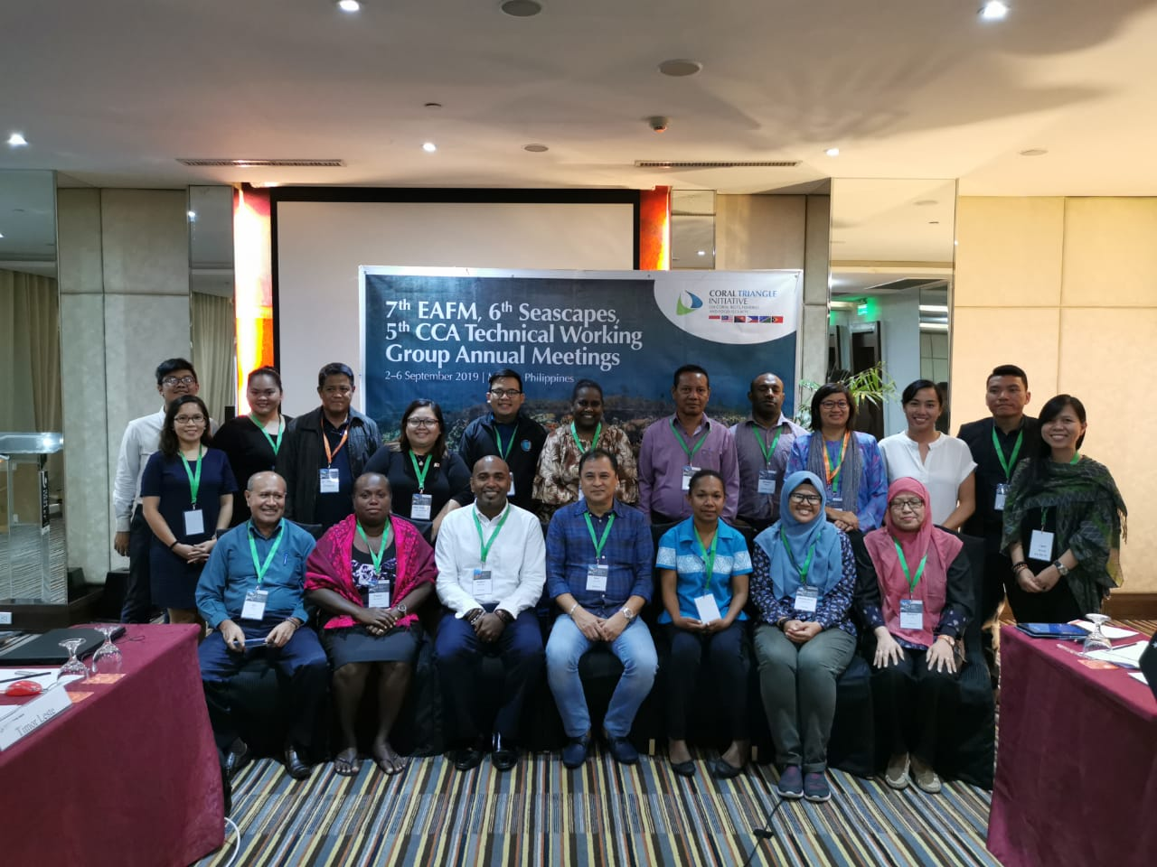
- Agreed to conduct a separate workshop next year for the finalization of CCA Executive Course with the following points:
Participants of the 6th CCA Technical Working Group Meeting held in Manila, Philippines. Photo credit: CTI-CFF RS/A. Anggorojati
- Realign the objectives based on recent developments i.e. RPOA 2.0, Blue Carbon, CEPA
- Design of the program will be general but the institutionalization will be country-specific
- Develop the program with specific target participants to identify and address their needs
- Papua New Guinea and Timor Leste to submit comments on the CCA Executive Course to the Regional Secretariat by 30th of September 2019
- Regional Secretariat to compile all the comments and present the same during the pre-SOM-15
- Noted that the Monitoring and Evaluation (M&E) indicators shall be updated upon approval of the full draft RPOA 2.0. In the interim, the current M&E indicators can be used for SOM-15
- Agreed that a separate workshop for M&E indicators shall be conducted once the RPOA 2.0 is finalized, subject to availability of funds
- Noted the outstanding task to develop the TOR of COE. However, also noted the discussion that the COE shall not be limited to CCA but also include other thematic areas. Therefore, agreed to recommend the following to SOM-15:
(1) to expand the TOR for COE to include all the thematic areas; and,
(2) to include the expansion of COE in the development of CTI-CFF RPOA 2.0

- Agreed that the priority of the initial proposed plan of action of CCA 2020 – 2024 is subsequently: (1) Capacity Building (Executive Course on CCA included); (2) Mapping of Coastal Vulnerability; (3) Development of Common Knowledge Platform; and (4) Coastal Management Policies, Rehabilitation, Protection; and it is noted that gender empowerment should be integrated into the identified priorities.

The full Chair’s Summary can be accessed at https://drive.google.com/drive/u/0/folders/12qZZPA-MeKzMoVa-OlJs8JbxavZ4qMFF

Threatened Species Working Group
- Regional Training on Identification of Sharks and Rays
Novotel Hotel, Lombok, Indonesia
February 25-27, 2019

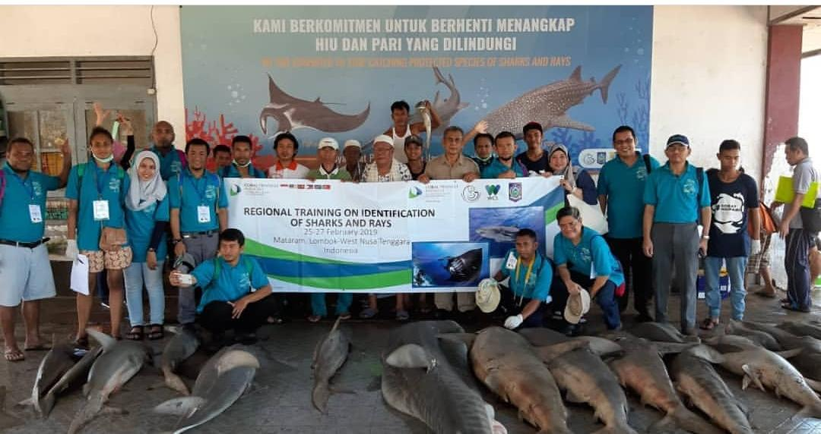
The CTI-CFF, Indonesia’s Ministry of Marine Affairs and Fisheries (MMAF) and Wildlife Conservation Society (WCS) joined in its efforts to build on existing systems and expertise to further develop capacity for shark and rays’ conservation in the CT region. The training was conducted also for relevant government institutions in CT region to enforce species protection laws and trade regulations as well as ensure legal and sustainable use and compliance with international national regulations.
Participants of the Regional Workshop on the Identification of Sharks and Rays held in Lombok, Indonesia. Photo credit: MMAF

One important highlight of the training was the suggestion to compile baseline data of sharks and rays in CT6 member countries for future management use and generic information since the data is not readily available.

- 3rd CTI-CFF Threatened Species Working Group
Horison Hotel, Gorontalo, Indonesia
September 17-19, 2019

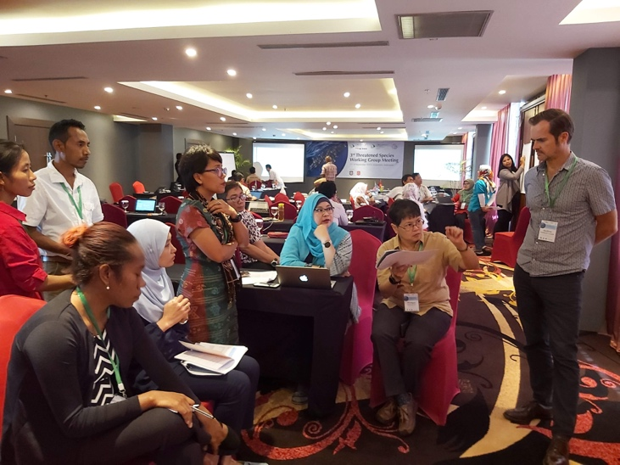
A recent peer-review study estimated that about 100 million sharks are fished every year to satisfy a market for their fins, meat, and liver oil. More than half of shark species and their relatives are categorized as threatened or near threatened with extinction.

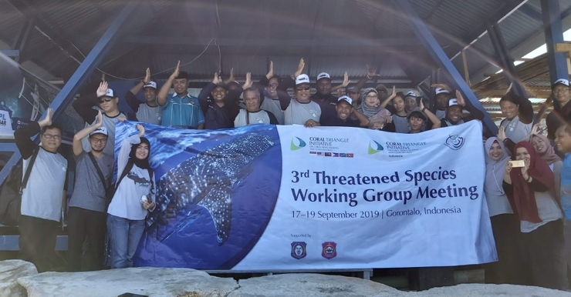
With this daunting scenario, the Threated Species Working Group (TS WG) of the CTI-CFF was fixed on the development of a regional conservation plan for marine mammals, sea turtles, shark and rays for its 3rd annual meeting. Development partners such as the Wildlife Conservation Society (WCS) and World Wildlife Fund (WWF) joined the TSWG in this effort.

In the meeting, the group agreed upon the following recommendations:
- Agreed that CT6 member countries shall submit their national conservation plan for marine mammals, sea turtles, sharks and rays to the Regional Secretariat for compilation by June 2020;
Top: Members of the TSWG together with the Development Partners discussing about M&E indicators. Bottom: The TSWG visited the Whale Shark Conservation Area in Botubarani Village, Bone Bolango, Gorontalo, Indonesia. Photo credit: CTI-CFF RS/J. Polita
- Agreed for the Writeshop of the Regional Assessment of Threatened Species and national conservation plan for marine mammals, sea turtles, sharks and rays to be included in the TSWG Workplan for 2020;
- Agreed to hire two consultants to assist the Regional Secretariat in compiling the Assessment of Threatened Species and National Conservation Plan of the CT6 member countries respectively, subject to availability of funds;
- Agreed to seek assistance from Development Partners to support the development of the Assessment of Threatened Species and National Conservation Plan of the CT6 member countries.

The meeting was hosted by the Government of Indonesia with support from the Provincial Government of Gorontalo and Bone Bolango Regency.

GOVERNANCE WORKING GROUPS

Financial Resources Working Group
- Financial Resources Working Group Meeting
Manado, North Sulawesi, Indonesia
February 11, 2019

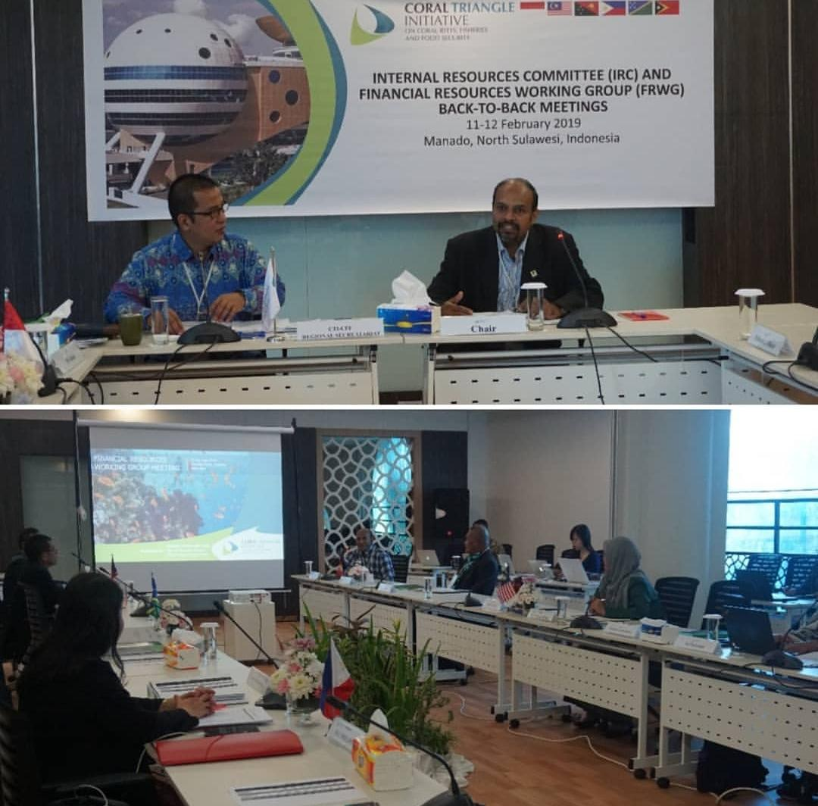
The meeting deliberated on the following points: (i) Revisit roles of FRWG; (ii) External Funding Institutions; (iii) CTI-CFF Financial Rules and Regulations and Financial Policies and Procedures Manual; and (iv) CTI-CFF Staff Rules and Regulations and Staff Policies and Procedures Manual and 2018 Annual Report.

Particularly, the meeting highlighted the importance of strengthening and establishing collaboration with Development Partners by reactivating the Development Partners - CTI-CFF Regional Secretariat physical meeting (including potential donor country/agencies); engage and organize formal meeting where possible, with potential donors and supporters like China, Korea, Japan, Norway and Sweden, Monaco, New Zealand, India and other like-minded countries/institutions.
The FRWG Meeting was chaired by Dr. Nagulendran Kangayatkarasu from the Government of Malaysia Photo credit CTI-CFF RS/J. Polita

The Working Group also noted to produce an Annual Report and endorsed the recommendation that all funds by donor country/partners shall be channeled to the CTI-CFF Regional Secretariat with a certain management fee based on international standards. This is taking into account that the CTI-CFF Regional Secretariat is now fully established and a legal entity since 2015, and as of 2017, the CTI-CFF Regional Secretariat has been registered and deposited at the United Nations Secretary General as intergovernmental organization.

Internal Resource Committee
Internal Resource Committee (IRC) Meeting
Manado, North Sulawesi, Indonesia
February 12, 2019

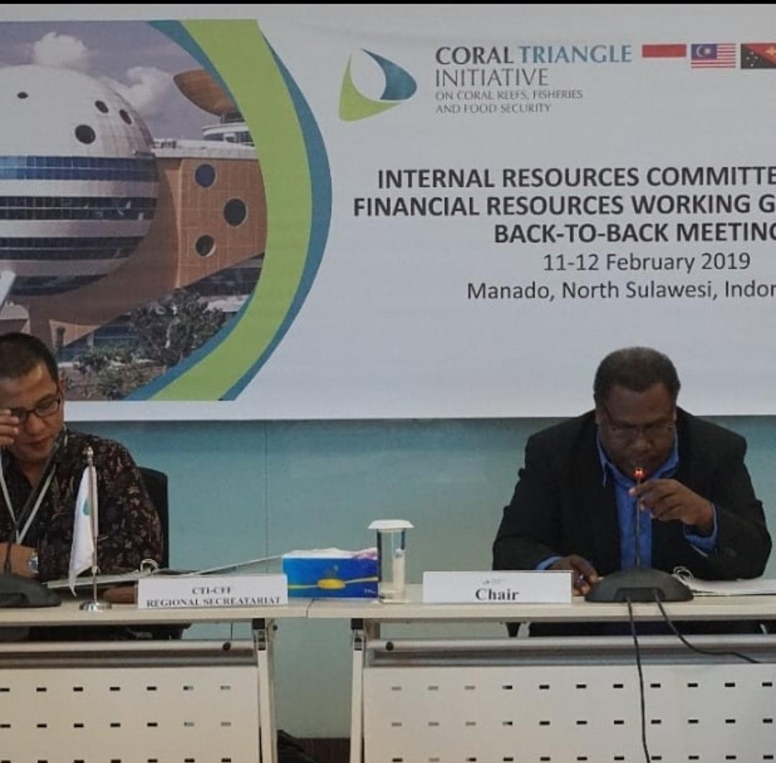
This year, the Internal Resource Committee (IRC) had its first meeting after the SOM-14 approved its creation with its primary role of providing an independent review of the internal resources of the Regional Secretariat and to recommend to the CTI Council of Senior Officers (CTI-CSO) the following: 1. Annual Budget; 2. Internal Audit & Acceptance of Annual Audit Report; and 3. Policy Directions pertaining to financial and asset management.

In the meeting, among the notable agreements were:
- Tasked the Regional Secretariat to align the result of the legal opinion from Indonesia’s Ministry of Foreign Affairs to the Staff Regulation and Staff Policies and Procedures Manual;
The IRC meeting was chaired by Alick Misibini from the Government of Solomon Islands. Photo credit CTI-CFF RS/J. Polita
- Agreed on the proposed amended Salary Scale of the CTI-CFF Regional Secretariat which refers to recommended Salary Scale by SOM-10 with two columns - Minimum and Maximum (based on Mid Salary)
- Agreed on the proposal of the capacity building of CT6 Member Parties CT6 Countries through the six Regional Coral Triangle Network Officers and its term of reference;
- Reiterated the decision made during SOM-14 on Session 7.2.g of Chair’s Summary which states, “Task the Regional Secretariat to consider putting the minimum grade scale salary for the new appointed ED and DED(s), taking into account the qualification and experience of the successful candidate;” and
- Agreed to use part of the cash surplus of USD 951,168 (as per 2017 audit report) in the following:
  - Recruitment costs of the Executive Director and Deputy Executive Director for Corporate Services
  - Renewal of the RPOA
  - Use for CT Atlas Redesign and Migration
  - Use for Capital Expenditure of CTI-CFF Regional Secretariat
- Tasked the CTI-CFF Regional Secretariat to seek the possibility for the Leaders’ Summit to be conducted in conjunction with APEC Summit in 2020 in Malaysia.
- Tasked the CTI-CFF Regional Secretariat to seek investment opportunity using available cash amounting to USD 426, 063 from the cash surplus USD 951,168

The full Chair’s Summary of the IRC Meeting can be accessed at https://drive.google.com/drive/u/0/folders/1ku8F-pfnNJeOlLQ3YiTKNMhzzHjDDPhh

Monitoring and Evaluation Working Group
Monitoring and Evaluation Working Group (MEWG) Meeting
Manado, North Sulawesi, Indonesia
May 2, 2019

The MEWG Meeting was conducted back-to-back with the conduct of the 1st Consultative Workshop on RPOA and the 3rd Regional Priority Setting Workshop in Manado, Indonesia. The meeting deliberated on RPOA 2.0, M&E indicators, emerging issues, Leaders’ Summit among others.

C.1. Renewal of the Regional Plan of Action

It has been 10 years since the six countries – Indonesia, Malaysia, Papua New Guinea, Philippines and Solomon Islands – endorsed and adopted the CTI-CFF RPOA 1.0, which has been the foundation for the program’s long term vision, goals, and actions to protect the environmental and economic assets of the Coral Triangle Region.

This year, the CTI-CFF Regional Secretariat is facilitating the renewal of the CTI-CFF Regional Plan of Action (RPOA 2.0) which is hoped to continue to provide a strong foundation for meeting the needs of coastal communities whilst maintaining and enhancing the Coral Triangle Region.

The preparation for the draft RPOA 2.0 is being handled by the PT. Hatfield Indonesia with Dr. Lida Pet-Soede as the Project Leader. The CTI-CFF Regional Secretariat appointed Dr. Nora Ibrahim, Deputy Executive Director for Program Services as the Review Manager.

A coordinated approach was applied to deepen the level analysis for effective planning and development of the draft RPOA 2.0. Series of workshops focusing on strategic communication, financial resource and institutional framework; country consultations; questionnaire; and meetings were conducted with various stakeholders to gather a wholistic perspective on the needs, challenges and opportunities facing the Coral Triangle Region today and look how to best position CTI-CFF.

a. 1st RPOA Consultative Workshop
Manado, North Sulawesi, Indonesia
29 April - 2 May 2019

Marine and environment conservationists, experts and key government officials from CT6 member countries gathered for a three-day consultation workshop to identify and discuss regional priorities for the CT region.

The consultation workshop was aimed at ensuring the RPOA 2.0 of the CT6 member countries are focused on the countries’ commonalities and consistent with positive impacts on shared concerns. Further, it was aimed at identifying strategies that are feasible and are aligned to global commitments as well as national targets across CT6 member countries.

The workshop noted that the impacts of the RPOA 1.0 are increased attention to marine and coastal issues, regional cooperation relevant to international commitment, and nurtured cooperative linkages between Southeast Asia and Pacific countries.

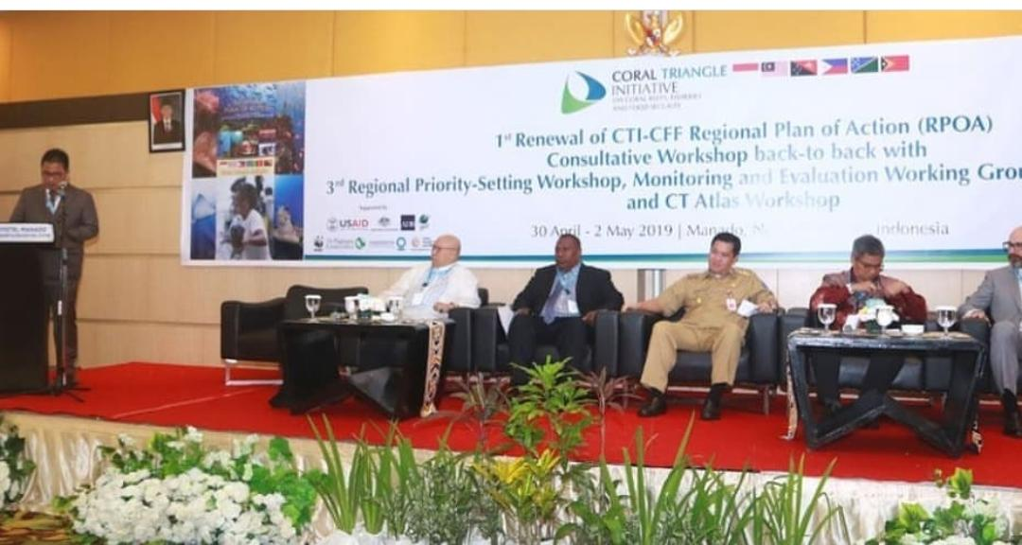
Further, it noted that CT Atlas, the Global Coral Reef Monitoring Network, Technical Working groups, governance working groups and cross-cutting initiatives are important and instrumental platforms in achieving the RPOA.
The Opening Ceremony of the 1st Consultative Workshop back-to-back with 3rd Regional Priority Setting Workshop, MEWG and CT Atlas Workshop. Photo credit: CTI-CFF/J. Polita

b. Strategic Communication Expert Workshop
Manila, Philippines
22- 23 May 2019

As part of the series of workshops for renewal of the CTI-CFF Regional Plan of Action, a Strategic Communication Expert Workshop was conducted last 22–23 May 2019 in Quezon City, Philippines. Attended by representatives from CT6 Members Parties and Development Partners namely, Coral Triangle Center and WWF, the workshop intended to provide relevant expertise to draft a strategic communications plan in support of the RPOA and compile further recommendations and relevant information.

The RPOA review suggested that closer integration of the CTI-CFF program into the activities of the lead government agencies involved in the program as well as other government agencies is needed. Further, CTI-CFF budget’s inclusion in the budget of Ministries or national planning agencies is needed.

Thus, these goals will require work to communicate the logic of working at a regional level clearly and more effectively to specific target audiences and individual decision makers. Also, the RPOA review noted the need for improved communications so that the CTI can avoid duplicating work that is already done by other regional organizations and focus on its core competencies or where it holds a competitive advantage.

c. Country Consultation and Online Questionnaires

Consultants from PT Hatfield conducted country consultation to the CT6 member countries to further draw information about the perspective regarding the RPOA 2.0.

On the other hand, the online questionnaires sent to NCCs, development partners, regional secretariat and other stakeholders sought to understand the respondent’s familiarity with the RPOA goals; opinions on specific statements about CTI-CFF and how they related to the CTI-CFF today; and opinions on the structure of Draft 1 of the RPOA 2.0 document, including: additionality, thematic consistency, commonality, and feasibility.

d. Financial Resource Strategy Expert Workshop
Singapore
July 31- August 1, 2019
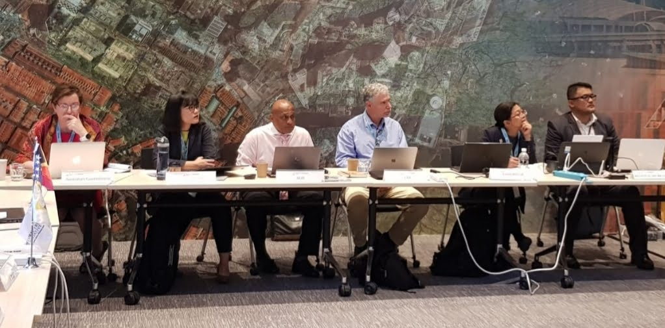
The workshop was attended by financial experts from CT6 member countries and development partners to recommend a sustainable financial mechanism for CTI-CFF. Photo credit: CTI-CFF RS/W. Winarbo
Financial experts and senior officials from CT6 countries, financial institutions and international non-government organizations gathered for a two-day workshop in Singapore to help draft a financial resource mobilization plan in support of the renewal of the CTI-CFF Regional Plan of Action, most commonly referred as RPOA 2.0.

In the workshop, participants were provided with a high-level summary of political, economic, environmental and social context to the CTI-CFF and its goals which served as a backdrop to consider options to mobilize financial resource for the goal of CTI-CFF. Particularly, the workshop noted that given the history of work done on finance mobilization of CTI so far, the need for good leadership, political will and alignment between the RPOA 2.0, donors and country priorities are important considerations for sustainable financing of CTI-CFF.

In the workshop, financial expert Dr. David Meyers from Conservation Finance Alliance discussed about conservation finance. ADB/GEF Senior Environment Specialist, Mr. Arunkumar Abraham introduced the new ADB Action Plan (2019–2024): Ocean Finance Initiative with a target of a 5 billion USD, committing to do more investments and technical assistance in Oceans and Blue Economy.

Potential cases on securing reef-related livelihoods, sharks and rays, ecosystems approach to financial management as well as national trust funds were also discussed as possible areas of investments of CTI-CFF. These cases were presented by Ms. Nicole Coombe of Australian government, Ms. Liza Matthews and Ms. Hollie Booth of Wildlife Conservation Society, Ms. Susan Roxas of WWF, and Ms. Laura Whitford of The Nature Conservancy respectively. A presentation on the Caribbean Challenge by Ms. Leah Carriere of YNC stimulated participants to think other financial mechanism approaches.

The workshop emphasized some of the important points: the need to prioritize finance options and solutions in order to make an effective workplan and task the right experts to start developing the finance solutions; a trust fund or blended approach to finance mobilization that will allow for a mix of financial solutions and mechanisms; and importance of a clear and communicable value proposition of the CTI-CFF to target audiences relevant for finance mobilization.

The workshop is made possible with the support from the entire WCS team, led by Mr. Martin Callow.

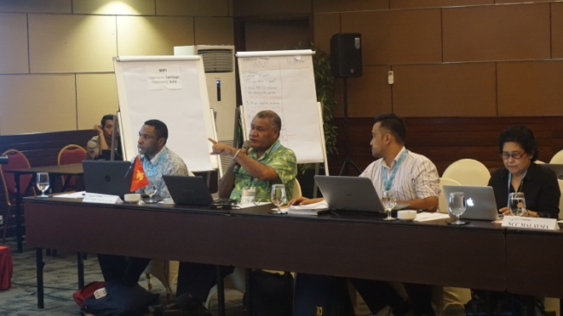
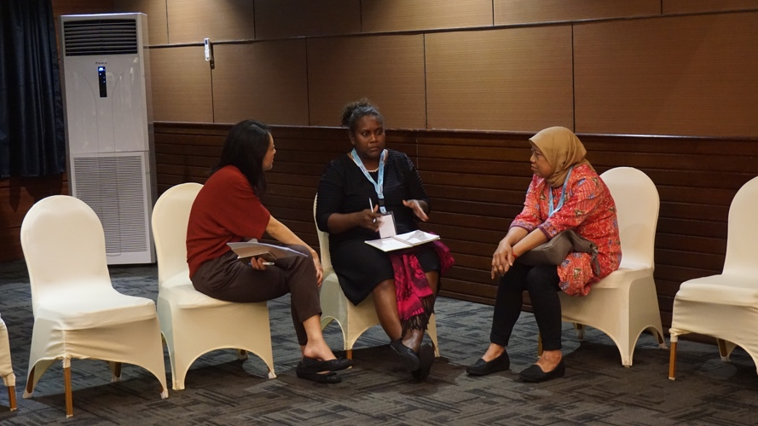
e. Institutional Framework Workshop and
The workshop participants from CT6 member countries and development partners discussed what they perceived the RPOA 2.0 should focused into. Photo credit: CTI-CFF RS/R. Wasturini
Writeshop
Bali, Indonesia
August 13-15, 2019

Building on the first CTI-CFF Regional Plan of Action (RPOA 1.0) review findings and considering the direction of the RPOA 2.0, senior officials from CT6 members countries, chairs of the CTI-CFF working groups and cross-cutting initiatives, as well as development partners sit down together to discuss the draft institutional framework and operational plan for an effective CTI-CFF in support of the RPOA 2.0.

The workshop drew from the participants’ view for RPOA 2.0 which highlighted the following: the need to build on past successes and address key challenges; must be relevant to CT national and regional priorities; CTI’s relevance and value-added must be demonstrated and its financial sustainability must be addressed; improvement on the internal operations and processes of RS; better partnerships; and NCCs should be strengthened.

Further, the workshop noted the importance of working groups (WGs), particularly in attracting support from potential donors and partners through its initiatives. Thus, financial support is need to cover the activities of the working groups. Further, the notable work of the WGs should be communicated. But the workshop also pressed on the need for working groups’ performance to be assessed through an effective M&E system.

In the end, the participants identified short-term to long-term recommendations to strengthen CTI-CFF. The immediate recommendations were completing the RPOA 2.0 at the highest professional level; preparing and implementing an institutional plan for the Regional Secretariat; clear statement on the value- added of CTI; identifying cross-sectoral and synergies between and among Working Groups; explore ways to strengthen NCCs; and for the incoming leadership Executive Director to meet key leaders of CT6 Member Parties to explain the relevance of CTI.

Change management experts Dr. Lida Pet-Soede of PT. Hatfield Indonesia and Mr. David Sheppard, former Director General of the South Pacific Regional Environment Programme (SPREP) facilitated the workshop. On the other hand, communication experts from WWF, CTC and PT. Hatfield helped in crafting the crisp narrative commitment statement for CTI to be reviewed by CT6 Member Partiesbefore its endorsement at the SOM-15 on November 2019 in Honiara, Solomon Islands.

The workshop was conducted for 1.5 days in Bali, Indonesia with support from US Department of Interior. The workshop was followed by a writeshop for the draft RPOA 2.0.

C. 2. CT Atlas Design and Migration
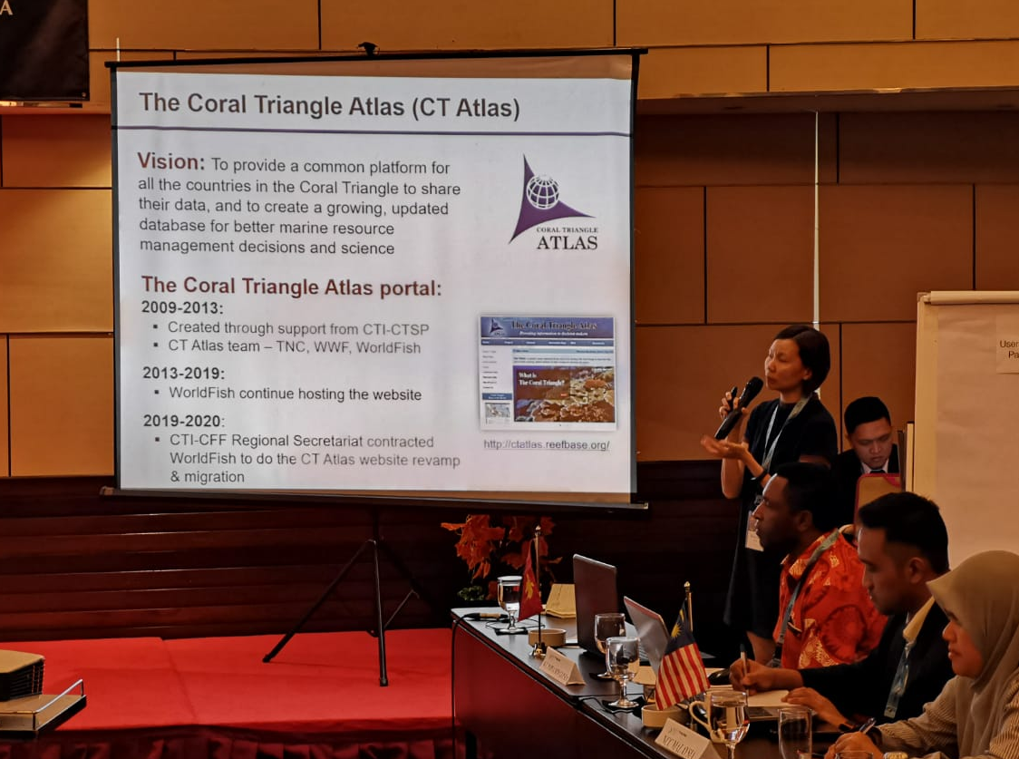
The work in redesigning the CT Atlas continues with WorldFish at the helm of the technical requirements and CTI- CFF providing the strategic vision for new CT Atlas development.

Ms. Shwu Jiao Teoh, IT expert and CT Atlas Technical lead from WorldFish, presented a simple, user-friendly and easy-to-the-eye look of the CT Atlas during her presentation at the Institutional Change workshop in Bali, Indonesia. The usual features of the CT Atlas were retained such as description about CT Atlas, CT6 country pro le, database, publication, interactive map, map and image gallery and M&E.
Ms. Shwu Jiao Teoh of WorldFish provided an update on the CT Atlas Migration among participants of the Institutional Framework Workshop in Bali, Indonesia. Photo credit: CTI-CFF/J. Polita

The CT Atlas architecture is currently being hosted through Microsoft Azure. On the other hand, CTI-CFF through its Regional Secretariat recently hired an IT Officer who will be closely coordinating and working with the WorldFish team for the smooth migration of the CT Atlas.

The CT Atlas is envisioned to provide a common platform for all the countries in the Coral Triangle to share their data, and to create a growing, updated database for better marine resource management decisions and science.

Prior to the Bali workshop in August 2019 where Ms. Teoh presented the update on the CT Atlas Design and Migration, she conducted an online survey among NCCs, development partners, Regional Secretariat and other stakeholders regarding CT Atlas where the result was presented during the 1st Consultative Workshop on RPOA 2.0 in Manado, Indonesia last May 2019.

Ms. Teoh together with Mr. Stanley Tan of WorldFish also trained the members of the MPA Working Group on inputting information/data to the CT Atlas database during the 8th MPA Regional Exchange and 8th MPA Technical Working Group Meeting in Kota Kinabalu, Sabah, Malaysia last 17 October 2019.

CROSS-CUTTING INITIATIVES

Local Government Network
Maritime Local Government Network roll up sleeves for Strategic Partnership and Resource Mobilization Planning
Jakarta, Indonesia
July 29-31, 2019

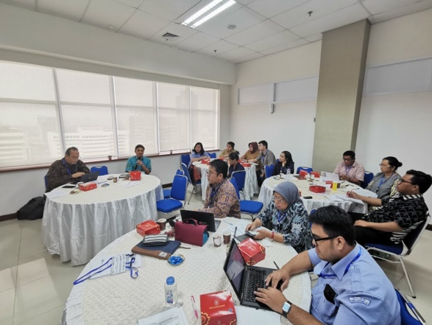
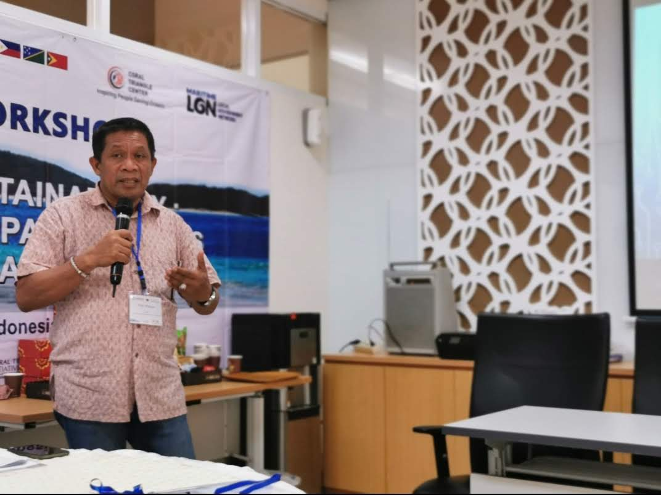
With the support from USAID and US Department of Interior, the Maritime Local Government Network (LGN) conducted a workshop to discuss and plan for its organizational strategic partnership and resource mobilization plan. Particularly, the workshop revisited and reviewed its strategic goals as well as determined its strategic priorities. It also explored the possible support and opportunity to further strengthen LGN identified priorities and came up with a draft financial sustainability action plan.
Top: Participants of the workshop revisited and reviewed LGN’s strategic goals as well as determined its strategic priorities.
Photo Credit: CTI-CFF RS /A. Anggorojati

Mr. Hugua, Chair of the LGN, noted the network has a total of 29 local government across the CT6 member countries. The LGN collaborated with UNESCO Jakarta and the Coordinating Ministry of Maritime Affairs to conduct a Regional Workshop on Building National and Local Capacity on Measuring Science, Engineering, Technology and Innovation (SETI) for SDGs in the Asia Pacific last June 2019. He said that currently the LGN is working on an MOU with Indonesia’s Ministry of Home Affairs for strengthening the capacity and performance of coastal and maritime local governments in conserving sustainable coastal and marine resources.

On the other hand, Dr. Hendra Yusran Siry, Interim Executive Director of CTI-CFF Regional Secretariat noted in his presentation that the network is a platform of the local government in the CT6 member countries to contribute to the regional goals of CTI, thus see the important role of the LGN. The workshop was hosted by the Indonesia’s Ministry of Marine Affairs and Fisheries.

Women Leaders Forum (WLF)
i. WLF Meeting
Dili, Timor Leste
June 27, 2019

The Women Leaders’ Forum (WLF) met last June 27, 2019 in Dili Timor Leste with NCC representatives and partners to discuss ways to synergize existing and future work in the region. The meeting also gathered inputs from the participants to be included into the draft gender policies/regulations matrix especially on the gaps and challenges, how women participation is included in planning and implementation process, gender equality integration. Further, the information will feed into the RPOA 2.0 process.

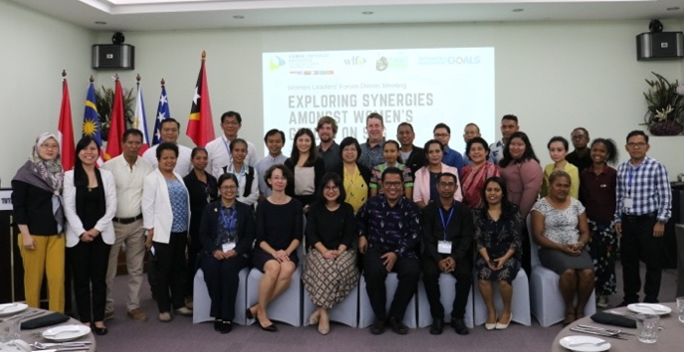
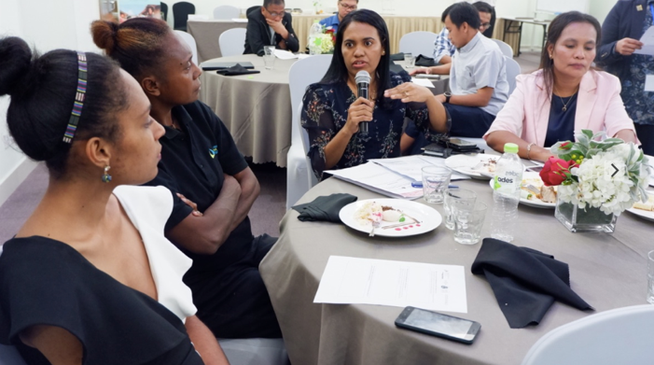
Resource persons during the meeting were Dr. Sharifah Nora Ibrahim of CTI-CFF Regional Secretariat; Dr. Arlene Satapornvanit of USAID Oceans; Ms. Jasmin Mohd Saad of USAID Oceans representing Ms. Agnetha Karamui, WLF Chair from Solomon Islands; Ms. Agustinha Duarte of WorldFish Timor-Leste; Ms. Lusitania Lopes of Women Maritime in Asia (WIMA); Ms. Kulthida Techasarin of US Department of Interior; Ms. Esmeralda Dos Santos of Timor-Leste NCC; and Ms. Bernadette da Fonseca of FAO Timor-Leste.

Malaysia and Papua New Guinea also shared their Gender/Women Initiatives. The WLF meeting was supported by USAID Oceans and US DOI hosted by the NCC Timor-Leste and co-organized by the CTI-CFF Regional Secretariat
Top: Ms. Lusitania Lopes of WIMA explained initiatives of their women’s group. Bottom: Participants from CT6 member countries and development partners gathered together for the WLF Dinner Meeting in Dili, Timor-Leste. Photo credit: CTI-CFF RS/J. Polita

ii. WLF Planning Meeting
Bali, Indonesia
July 22-23, 2019

Ensuring gender mainstreaming in all CTI-CFF programs, members of the CTI Women Leaders Forum met up to identify and plan activities in Bali, Indonesia. In the meeting were Ms. Patricia Bickley of US DOI; Dir. Rili Djohani, Ms. Susantry, and Ms. Leilani Gallardo of Coral Triangle Center (CTC); and Dr. Nora Ibrahim of CTI-CFF Regional Secretariat of CTC met to identify and plan activities. They were also joined by USAID consultant Mr. Robert Schout.

The group were able to identify two activities for implementation this September 2019. First, a training that targets women leaders (supervisors, managers, and academics) in marine and coastal conservation areas in the CT6 member countries. The training is intended to amplify the impact of women leaders to influence their organizations and build the capacity of more women to take on leadership roles in marine and coastal management in the region. The second activity is a two-day workshop and a 1-day write shop to generate inputs and insights from CTI-CFF stakeholders on how to integrate CTI-CFF’s cross cutting initiatives into the RPOA 2.0. The activity is targeting representatives from the CTI-CFF National Coordinating Committees and Regional Secretariat, development partners and cross-cutting initiative stakeholders.

The planning meeting was organized by the Coral Triangle Center and supported by US Department of Interior.
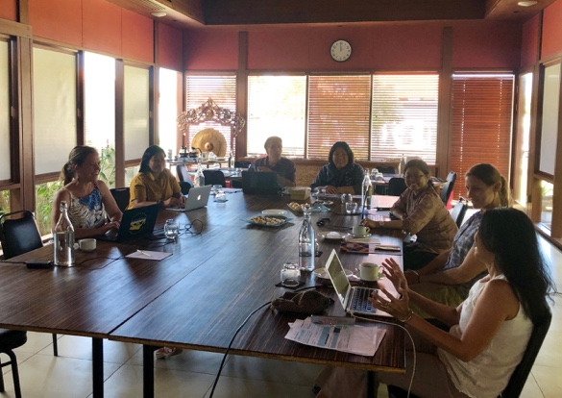
Ensuring gender mainstreaming in all CTI-CFF programs, members of the CTI Women Leaders Forum namely (from left to right) Ms. Patricia Bickley of US DOI; Ms. Susantry and Dir. Rili Djohani of Coral Triangle Center (CTC); Dr. Nora Ibrahim of CTI-CFF Regional Secretariat); Ms. Kitty and Ms. Leilani Gallardo of CTC met to identify and plan activities. They were also joined by USAID consultant Mr. Robert Schout.

The meeting was organized by Coral Triangle Center and supported by US DOI.
Photo Credit: US DOI/Patricia Bickley

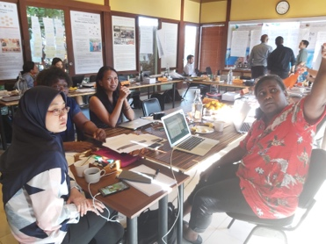
iii. Workshop on Aligning Cross-Cutting Initiatives (CCI) to the CTI-CFF Regional Plan of Action 2.0 & The CTI-CFF Women Leaders’ Forum Developing a Competency
Model to Elevate Women Leadership in Marine and Coastal Management
Coral Triangle Center, Bali, Indonesia
September 24 – 26, 2019
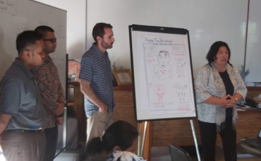
The CTI-CFF Regional Secretariat participated in the workshop on Aligning Cross-Cutting Initiatives to the CTI-CFF Regional Plan of Action 2.0 which brought together senior officials from NCCs and key leaders of WLF, LGN and Regional Business Forum. In said workshop, the three (3) Cross-Cutting Initiatives came up with an Action Plan that identified key activities and outputs for immediate action, short-and long term periods, which are all aligned to the CTI-CFF RPOA 2.0.
CCI – WLF, RBF, and LGN discussed and shared their Action Plans in relation to contributing to the RPOA 2.0 of CTI-CFF. Photo credit: CTI-CFF RS/J. Polita

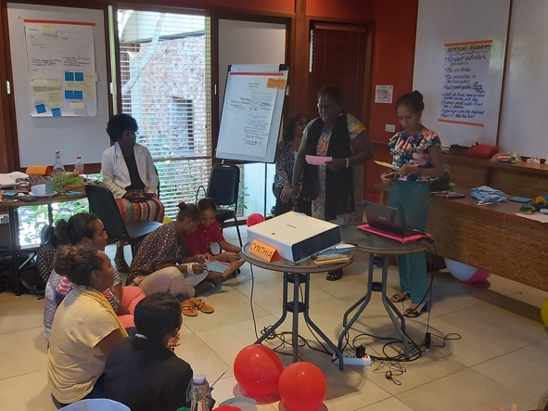
In parallel with the workshop was the CTI-CFF Women Leaders’ Forum Developing a Competency Model to Elevate Women Leadership in Marine and Coastal Management.
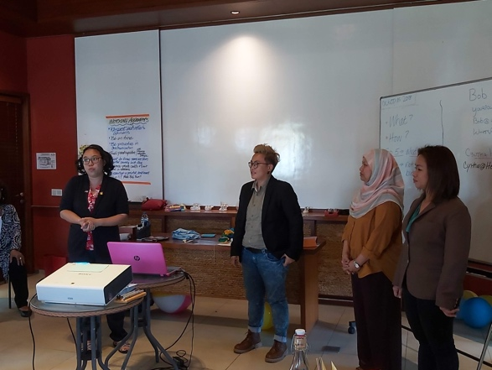
The activity was aimed at developing a customized leadership competency model for women leaders across the Coral Triangle region. This model and portfolio includes: a competency model and framework, a list of skills and knowledge associated with each competency and a sampling of educational resources that will support leadership development, and tips for integrating the competencies in each organization, aiming to provide more women leaders with the capacity needed to champion marine and coastal resource management.
Women leaders from CT6 member countries shared the many competency skills of women leaders and the various ways to further enhance these skills through role playing and video presentation. Photo credit: CTI-CFF RS/J. Polita

V. Capacity Building Program for Regional Coral Triangle Network Officers (RCTNO)

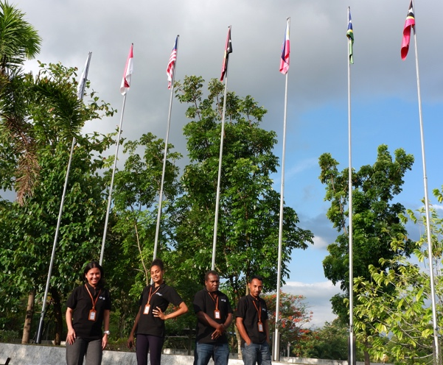
The CTI-CFF through its Regional Secretariat (RS) is implementing the Capacity Building Program for RCTNO. The 5-month program intends to provide learning experience on improving the implementation of the current Regional Plan of Action (RPOA); to be involved and contribute in the renewal of RPOA process; to improve understanding of RS functions; to provide opportunity on improving and strengthening the linkages of NPOAs to the RPOA; and act as focal points between RS and their respective NCCs for communication assistance.
The RCTNOs from Indonesia, Papua New Guinea, Solomon Islands and Timor-Leste have the opportunity to learn more the work of CTI-CFF Regional Secretariat through various exposure activities such as attendance in workshops, meetings and the like. Photo credit: CTI-CFF RS/R. Wasturini

The program gathered one (1) nomination from each CT6 member countries who are young professionals working in the field of marine/coastal ecology, fisheries science, management, monitoring and other relevant fields in government department of the countries. The Regional Secretariat has four RCTNO in the headquarters namely Dr. Conni Sidabalok (Indonesia), Ms. Phelameya Haiveta (Papua New Guinea), Mr. Simeon Baeto (Solomon Islands) and Mr. Sabino Adonia (Timor Leste). They officially started their program at RS last July 15, 2019.

The RCTNOs have been exposed to numerous activities of the Regional Secretariat particularly relating to RPOA 2.0. Moreover, the RCTNO have been helping the Regional Secretariat in its various facilitation and coordination work relating to Technical Working Group, Governance Working and Cross-Cutting Initiative such as documentation of activities, preparation of workshop materials and activity report, attendance in trainings and meetings and facilitation of activities.

The RCTNOs particularly attended the following activities:
- Institutional Change Workshop and Writeshop for RPOA in Bali, Indonesia
- Threatened Species Working Group Meeting in Gorontalo, Indonesia
- Training on Financial Literacy and Management for Women in Fisheries in Bitung, Indonesia
- Workshop Towards the Sustainable Fishery Management in North Sulawesi through EAFM approach in Manado, Indonesia

VI. Partnerships and Potential Regional Programs
The development partners have been valuable in supporting and ensuring the sustainability of the CTI-CFFs efforts by providing technical and scientific expertise; funding for priority conservation and sustainability projects; and activities at the regional, national and community level. The following are activities implemented in collaboration with development partners:

USAID Strengthening Organizational and Administrative Capacity for Improved Fisheries Management (SOACAP)

This year, the US Department of Interior continued its support to the CTI-CFF by funding the following activities:

- 3rd Regional Priority Workshop for RPOA 2.0 in Manado, Indonesia last May 1, 2019
- Workshop on CDT System Design and Development based on EAFM in Dili, Timor Leste last June 25-26, 2019
- Workshop on Institutional Change for effective of CTI-CFF in Bali, Indonesia last August 13-14, 2019

Australian Government Support

This year, the Australian Government supported the Strategic Communication Expert Workshop last May 22-23, 2019 in Manila, Philippines. Output of the workshop was a draft Strategic Communication Workshop which highlighted key officials, development partners and international/global organizations as primary audiences. It also produced key4 communication goals and three key messages.

- Development Partners Meeting
Singapore
25-28 June 2019

With Singapore, the global financial center as backdrop, the CTI-CFF Development Partners discussed plans as a partner role in addressing gaps or required action in the CTI-CFF RPOA 2.0.

Senior officials from Government of Australia, Coral Triangle Center, The Nature Conservancy, Wildlife Conservation Society, World Wildlife Fund and USAID Regional Development Mission for Asia also discussed the outcomes from the CTI-CFF Finance Resource Strategy Expert Workshop and analyze how this fit in the RPOA 2.0.

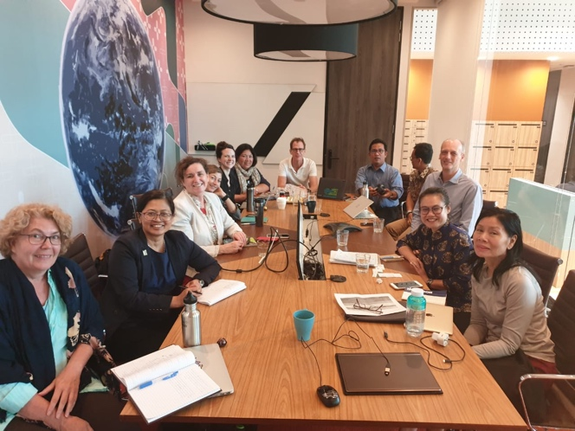
Development Partners also sit down with the management and finance team of the CTI-CFF Regional Secretariat (RS) to have a common understanding of respective priorities, concerns, gaps (such as LGN and Regional Business Forum), and capabilities with respect to the RPOA completion and implementation. Areas where partners can support were also laid down. The need to socialize the RPOA 2.0 between the writeshop and SOM-15 along with an Impact Assessment Report is seen as an important activity. It was also noted that the incoming Executive Director is important with the RPOA 2.0 coming to the fore.
Senior officials from Government of Australia, Coral Triangle Center, The Nature Conservancy, Wildlife Conservation Society, World Wildlife Fund and USAID Regional Development Mission with CT)-CFF Regional Secretariat discussed the outcomes from the CTI-CFF Finance Resource Strategy Expert Workshop and analyse how this fit in the RPOA 2.0

The meeting also highlighted support of development partners to promote message of commitment to audience at high levels. Furthermore, support to build capacity of RS staff as a team and technical assistance to CT6 member countries were noted.

Other Cooperation Activities

To build and renew partnership with government and potential donors, the CTI-CFF Regional Secretariat paid courtesy visits to the following embassies and international organizations:

- Ambassador Solomon Islands
- Ambassador Timor Leste
- Ambassador Australia
- Ambassador Norway
- Ambassador German
- Secretary General ASEAN Secretariat
- Ambassador European Union
- Consulate General Philippines in Manado

Courtesy Visit to Ambassadors
Courtesy visit to several Ambassadors of CTI CFF Members Parties, development partners and potential partners were conducted to provide an update of the CTI-CFF and seek potential strategic engagements. All Ambassadors welcomed Dr. Hendra Yusran Siry, the Interim Executive Director (IED) of the CTI-CFF Regional Secretariat and congratulated him for his appointment by the Government of the Republic of Indonesia to be the IED replacing the former ED Dr. Widi Agoes Praktikto who retired due to serious health condition on the 10th of June 2018.
One of the ambassadors visited by the Regional Secretariat was Australia’s Ambassador to Indonesia H.E. Gary Quinlan AO.

Ambassadors expressed their satisfaction on the progress made by CTI-CFF in the role of safeguarding and introducing sustainable marine economic in the Coral Triangle region. IED indicated the need for CTI-CFF to further build its relations with other potential partners.

CTI-CFF and ASEAN

The CTI-CFF Regional Secretariat led by Dr. Hendra Yusran Siry, Interim Executive Director paid courtesy visit to ASEAN Secretary General Excellency Dato’ Paduka Lim Jock Hoi with the aim of strengthening ASEAN-CTI-CFF collaboration last 18 February 2019 in Jakarta, Indonesia.

ASEAN Secretary General Dato’ Paduka Lim Jock Hoi stated that the Coral Triangle’s corals must be protected, and that the CTI-CFF is an important forum for marine conservation and fight against illegal unreported and unregulated (IUU) fishing. He also emphasized the importance of using local expertise. Further, he offered the ASEAN Secretariat’s support to the CTI-CFF RPOA 2.0 processes and requested participation in said matter.

During the meeting, the ASEAN Secretariat committed to inform relevant ASEAN WGs about CTI-CFF and potential for CTI-CFF to participate as stakeholder in the relevant ASEAN WGs.

During the courtesy visit, CTI-CFF Regional Secretariat had a back-to-back meeting with the Director of Corporate Affairs of the ASEAN Secretariat Mr. Ung Srengkong. The meeting was intended for CTI-CFF Regional Secretariat to learn ASEAN’s Secretariat’s experience in implementing its role and function as an intergovernmental organization in Indonesia.
The Regional Secretariat composed of Dr. Hendra Yusran Siry, Dr. Sharifah Nora Ibrahim Mr. Asa Silalahi met with ASEAN Secretary General Dato Paduka Lim Jock Ho (third from left). In the meeting were also from left, Dr.Pham Quang Minh, Asst. Director , Head of Food, Agriculture and Forestry Division, ASEAN Sectoral Dev’t Directorate; and Dr. Vong Sok, Asst. Director, Head of Environmental Division, ASEAN Sustainable Directorate. Photo credit: CTI-CFF RS/A. Anggorojati.
CTI-CFF and EU

Ambassador of the EU Mr. Vincent Guerend welcomed Dr. Hendra Yusran Siry, the Interim Executive Director (IED) of the CTI-CFF Regional Secretariat and congratulated him for his appointment by the Government of the Republic of Indonesia to be the IED replacing the former ED Mr. Widi Agoes Praktikto.

Ambassador Guerend was accompanied by Michael Bucki (Counselor for Climate Change and Environment) and Daniele De Bernadi (Program Manager for Environment, Climate Change and Forestry) in the meeting while Dr. Hendra was accompanied by the Executive Officer, Mr. Asa Silalahi.

Ambassador Guerend expressed his satisfaction on the progress made by CTI-CFF in the role of safeguarding and introducing sustainable marine economic in the Coral Triangle region. He informed that EU has also similar concern with CTI-CFF in relation with conservation and sustainable use of marine biodiversity resources and pointed out that EU foreign policy are, amongst other, forging regional and international cooperation. Thus, EU stands ready to further develop ventures with CTI-CFF.

Dr. Hendra also indicated the need for CTI-CFF to further build its relations and invite the European Union to become partners of CTI-CFF. He discussed possible future ventures in low-carbon development, preservation of biodiversity, promoting climate resilience and connecting economic and environmental gains. He informed Ambassador Guerend that CTI-CFF Regional Secretariat is the primary body that coordinates the implementation of the Regional Plan of Action. The Regional Secretariat also provides technical and coordination support to the NCCs on matters related to the goals and targets of the RPOA.
The CTI-CFF Regional Secretariat team also met with European counterpart team led by Dr. Puricacio Canals, Chair of Mediterranean Protected Area Network (MedPAN) with Mr. Filip Foster from GOPA Worldwide Consultants. The European team was joined by Mr. Klaas Teule, WWF Coral Triangle Program Leader. The group met to discuss potential synergy regarding strengthening ocean governance through European Union assistance.
The Regional Secretariat met with European team Dr. Puricacio Canals, Chair of Mediterranean Protected Area Network (MedPAN) with Mr. Filip Foster from GOPA Worldwide Consultants (second the third from left). The European team was joined by Mr. Klaas Teule, WWF Coral Triangle Program Leader. The group met to discuss potential synergy regarding strengthening ocean governance through European Union assistance. Photo credit: CTI-CFF RS/J. Polita

Participation in International/Regional Events
The CTI-CFF Regional Secretariat participated in the following events in order to share information and promote goals of the CTI-CFF to other regional groupings that share or in congruence with the goals of the CTI. The CTI0CFF participated in these activities to build new alliance and attract support to the initiatives of the CTI.

i. International Conference on Regional Cooperation for the Protection of the Marine Environment
Singapore
January 15-16, 2019

With the aim to investigate cooperative mechanisms by the numerous existing regional bodies and possible ways forward to improve the state of the marine environment in the region, the NUS Centre for International Law (CIL) organized the International Conference on Regional Cooperation for the Protection of the Marine Environment. The K.G. Jebsen Centre for Law of the Sea, UiT Arctic University of Norway supported the conference. Dr. Nora Ibrahim was invited to present at two sessions.

The conference investigated regional cooperation efforts by the numerous existing regional body and explored possible ways forward to improve the protection and management of the marine environment in the seas of Southeast Asia. One of the leading research questions addressed at the Conference was the extent to which the many ASEAN documents on the marine environment have incorporated, refer to or are de facto implementing obligations under international law to preserve and protect the marine environment.

At the conference, plastics and ship source pollution were also discussed as key marine environmental in Southeast Asia. The particular challenges of the region were explored, including legal, and political issues, the role of science and financial assistance. The final discussion centred on the way forward and protects for enhanced cooperation within ASEAN.

- 51st Meeting of the SEAFDEC Council
Shangri-La Hotel, Surabaya Indonesia
March 18-22, 2019

The meeting was intended to discuss matters on the policies and consideration on important issues, programs relevant to the As partner of SEAFDEC, the CTI-CFF Regional Secretariat on important issues, programs relevant to the present situation in regional fisheries and ne proposals or endorsement as well as results of implementation of programs based on the Resolution and Plan of Action adopted by the ASEAN-SEAFDEC Member countries in 2018.

- Boao Forum for Asia (BFA) Annual Conference: Maritime Security in the Asia Pacific Cooperation , Order and Rules
Boao, China
March 31, 2019

In this forum, Dr. Hendra Yusran Siry expressed CT6 countries’ commitment to continue action to create real change and work together to sustain extra ordinary marine and coastal resources by addressing crucial issues such as food security, climate change and marine biodiversity. Further, he welcomed any support from like-minded organizations in the global, regional and national to align and integrate the efforts with the concept and application of conservation and sustainable development of oceans, seas and coastal resources.

The forum was organized by the National Institute for South China Sea Studies and Center for International Strategy and Security, Tsinghua University.

iv. 12 the Intergovernmental Session of IOC WESTPAC
Manila, Philippines
April 2-5, 2019

The session brought together national competent governmental agencies and marine scientific communities aiming to improve science-policy interface. Advance international cooperation on marine science, observations and service and to enhance institutional capacities to address critical challenges to sustainable development in the Western Pacific and its adjacent regions. At this session, WEST-PAC will deliberate on and come up with concrete action plans towards future strategic and programmatic developments in the context of the 2030 Agenda for Sustainable Development and the UN Decade of Ocean Science for Sustainable Development (2021-2030).

In the meeting, the CTI-CFF Regional Secretariat through Dr. Hendra Yusran Siry remarked that the CTI-CFF Technical Working Group are also working on the efforts on coral reef resilience. Further, he noted that the CTI-CFF Scientific Advisory Group and University Partnership can be tapped for possible collaboration on critical research needs on coral reef bleaching.
Dr. Hedra Yusran Siry during his presentation at IOC WESTPAC, called for joint capacity building and strengthening research activities on coastal and reef ecosystems resilience in the face of climate change; enhanced access to updated data and information system; and sharing of tools and methodologies. Photo credit: CTI-CFF RS/J. Polita

v. Women Maritime Asia Regional
Conference
Kuala Lumpur, Malaysia
April 9-11, 2019

The CTI-CFF Regional Secretariat participated in the Women Maritime Asia Regional Conference with the theme “Empowering Women in Maritime Bridging the Gap”. The conference was supported by the International Maritime Organization (IMO). Dr.Nora Ibrahim, Deputy Executive Director for Program Services to speak at the conference.

The conference was aimed to provide support to women managers in maritime and port sectors with the goal of strengthening WIMA Asia to further promote the role and contribution of women to the maritime sector among others.
Dr. Sharifah Nora Ibrahim (second from right), together with Ms. Jasmin Mohd Saad, USAID Ocean’s Coordinator for CTI-CFF Women Leaders’ Forum; Ms. Aminath Jihaan and Ms. Mariyam Hameeda from Maldives.

vi. Meeting of the Coordinating Body on the Seas of East Asia (COBSEA) Technical Working Group on Marine Litter, and at the COBSEA Intergovernmental Meeting
Bali, Indonesia
June 19-20, 2019
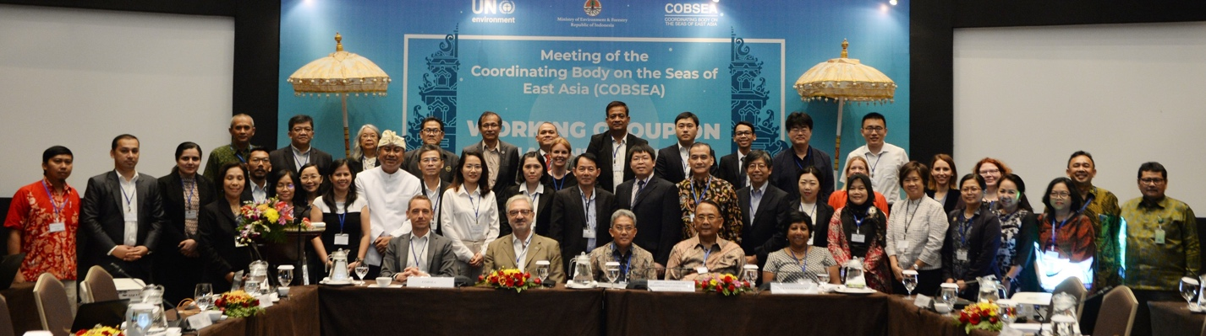
Participants of the Meeting of the Coordinating Body on the Seas of East Asia (COBSEA) Technical Working Group on Marine Litter.

At the in Bali Indonesia, CTI-CFF Regional Secretariat participated and emphasized the renewed relevance of the CTI-CFF Regional Plan of Action (RPOA 2.0) that would focus on the resilience of the ocean and coastal communities.

In the meeting, CTI-CFF through the Regional Secretariat expressed that the UNEP
COBSEA and CTI share common purpose in good ocean governance, including aiming for improvement of social and economic livelihoods of coastal communities in the Coral Triangle area. The CTI-CFF would focus on its core competencies and comparative advantage by aligning more strategically with, among others, the COBSEA”.

In the first meeting on the WG on Marine Litter, Dr. Sharifah Nora guided COBSEA WG on Marine Litter by informing that CTI focus on ocean’s resilience would be on coral reefs, mangrove forests, mudfats, seagrass beds, and endangered species. The RPOA 2.0 will address cross-cutting and emerging themes such as Marine Litter and plastics. Negative impacts of marine debris on threatened species such as sea turtles, cetaceans, dugongs, seabirds, etc would be addressed.

Issues such as Food Security and Sustainable livelihoods are basic to the coastal communities’ resilience and are high priorities in the RPOA 2.0. COBSEA WG meeting on Marine Litter and the COBSEA Intergovernmental Meeting were organized by the United Nations Environment Programme (UNEP) and the Coordinating Body of the Seas of East Asia (COBSEA) together with the Government of the Republic of Indonesia–The Ministry of Forestry and Environment and Forestry. CTI-CFF Regional Secretariat was represented by Dr. Sharifah Nora and Mr. Asa Silalahi.

vii. Workshop on Incorporating Blue Carbon into Nationally Determined Contributions (NCDs): Integrating Science with Policy Discourse to Address Climate Change and Achieve in Sustainable Development in Asia Pacific Region
Hanoi, Vietnam
July 8-12, 2019

In this workshop, the Regional Secretariat shared the common views with the Center for International Forestry Research (CIFOR) on the importance of conservation and restoration of coastal ecosystems, including tidal salt marshes, seagrass meadows, and mangrove forests (collectible called blue carbon ecosystems), as excellent nature-based solutions for climate change mitigation and adaptation.

As a follow-up activity, the CTI-CFF Regional Secretariat encouraged CIFOR to do a study and develop strategic blue carbon opportunities in Coral Triangle Region through a Review on Understanding Strategic Coastal Blue Carbon Opportunities, which covers the following topics:
- What is the status of blue carbon ecosystems in Coral Triangle Region?
- What are the rate of loss and scale of emissions in Coral Triangle Region?
- How does blue carbon fit with National Climate Commitments and Policies in Coral Triangle Region?
- What are the actionable steps to advance management in Coral Triangle Region?
- What opportunity for blue carbon finance mechanisms developing in Coral Triangle Region?

viii. PEMSEA 11th Partnership Council Meeting
Surabaya, Indonesia
July 2019

At the PEMSEA 11th Partnership Council Meeting, CTI-CFF expressed its desire to expand cooperation with PEMSEA particularly in strategic coastal blue carbon opportunities in the Coral Triangle region.

Dr. Hendra Yusran Siry informed the potential for both CTI and PEMSEA to explore cooperation with local government network to further promote its same agenda of addressing challenges and state of health of the East Asian Seas.

As the pioneer of integrated coastal management (ICM) in East Asia, PEMSEA provides integrated solutions for effective management of coastal and marine areas, supporting sustainable economic growth and blue economy, ecosystem rehabilitation and protection and adaptive and resilient communities.

Currently, PEMSEA’s leadership in the region is being challenged to maintain its role as a leader, expert and convener on coastal and ocean issues, brokering agreements and new fundraising opportunities. But PEMSEA is still committed in its pursuit to set the region’s direction in addressing new and emerging issues and relevant international commitment.

viii. 13th Meeting of the Ocean and Fisheries Working Group - APEC
Puerto Varas, Chile
August 20-21, 2019

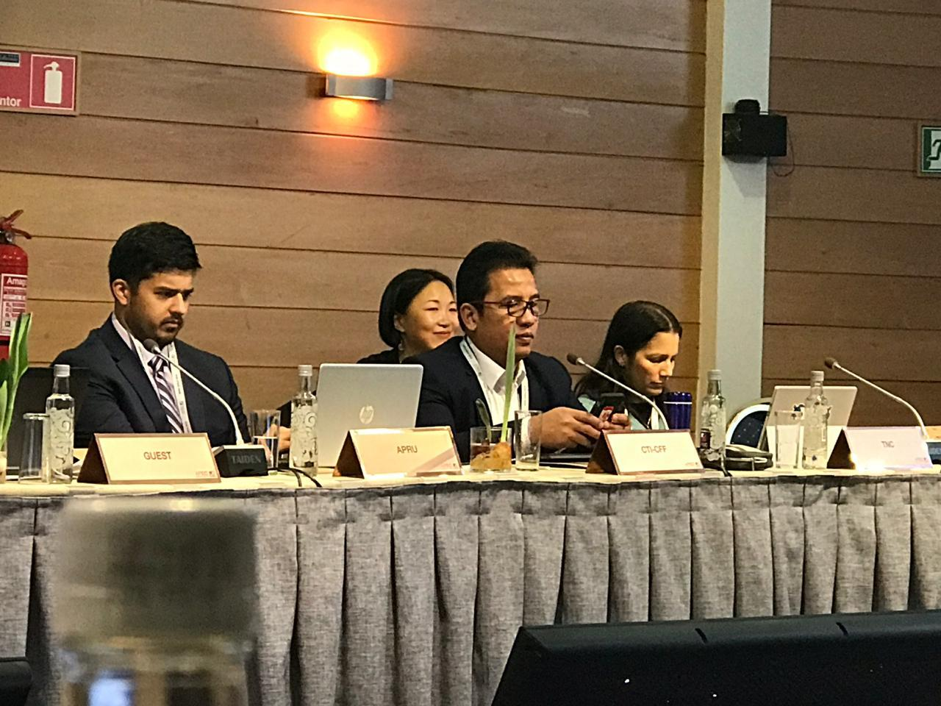
CTI-CFF through the Regional Secretariat participated in the 13th Meeting of the Ocean and Fisheries Working Group of the APEC held last August 20–21, 2019 in Chile.
Dr. Hendra Yusran Siry introduced CTI-CFF and called for the inclusion of CTI-CFF Leaders’ Summit at the APEC Summit in 2020 in Malaysia.

In the meeting, Interim Executive Director, Dr. Hendra Yusran Siry highlighted the CTI-CFF’s efforts through the Coral Triangle Marine Protected Areas System (CTMPAS) and the Women Leaders Forum as well as promotion of applications of catch documentation and traceability (CDT) data on fisheries capture to improve fisheries management and deter IUU fishing practices. Current work on the renewal of the CTI-CFF RPOA 2.0 was also highlighted.

Dr. Siry proposed to the OFWG to include the 2nd CTI- CFF Leaders’ Summit during the 2020 APEC Economic Leaders’ Summit in Malaysia, noting that it was introduced at the APEC Economic Leaders’ Meeting in Sydney in 2007, which resulted to a Leaders’ Declaration on Climate Change, Energy Security and Clean Development. Further, he proposed of joint activities on coral reefs, fisheries and food security.

In that meeting, APEC Indonesia remarked that Indonesia would like to develop the center in Manado as an APEC Center of Excellence (COE) for coral reefs, fisheries, mangroves, and blue carbon, inviting all economies to engage. Malaysia indicated that its high officials would consider the possibility of recognizing the center in Manado as APEC COE.

ix. NOAA Coral Reef Conservation Program Learning Network Exchange – Creating a Community of Practice workshop
Washington D.C., USA
August 20-27, 2019

The CTI-CFF through the Regional Secretariat attended the which was hosted by the World Bank in Washington, D.C. On behalf of CTI-CFF, Dr. Hendra Yusran Siry presented the capacity building and networking programs of the CTI-CFF namely the Regional Coral Triangle Network Officer (RCTNO) and Coral Triangle Marine Protected Areas System (CTMPAS).

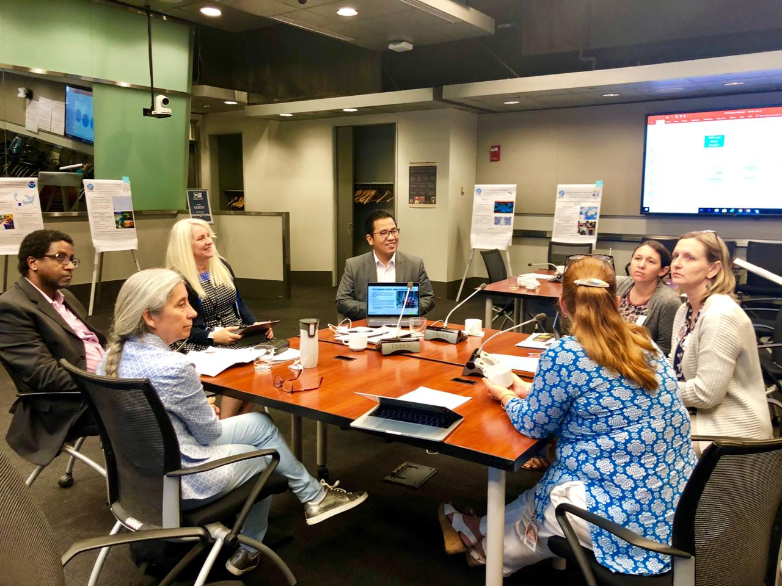
Building on NOAA Coral Reef Conservation Program’s (CRCP) new strategic plan, the workshop was aimed at developing a Community of Practice to help strengthen and support capacity building programs and learning networks (both internationally and domestically) in which NOAA is engaged. The workshop also aimed at defining a framework for a more holistic approach to capacity building that not only includes learning exchanges, but also focuses on knowledge management and post-exchange support. Key metrics were also developed to measure the success and value of supporting learning networks and from creating a Community of Practice.
Dr. Hendra Yusran Siry shared the capability building efforts of CTI-CFF through the RCTNO and CTMPAS

x. Sustainable Development of Marine Tourism and Conservation Management
Hotel Sheraton Bandara, Banteng, Indonesia
September 30, 2019

In this event, participants discussed the roles and challenges that will be faced by the provincial government and national government of Indonesia for the effective management of marine protected area and sustainable marine tourism. The Regional Secretariat shared its efforts, particularly the activities of the MPA Working Group.

The activity was participated un by various government and international non-government agencies in Indonesia.

xi. 6th ASEAN Heritage Parks Conference
Pakse, Lao, PDR
October 21-24, 2019

The Regional Secretariat participated in this event through Dr. Sharifah Nora Ibrahim, Deputy Executive Director for Corporate Services as a resource persons on the Parallel Break-out Session1: Fulfilling Aichi Biodiversity Target 11 in East and Southeast Asia which was held on Day 2 of the Conference. Further, the Regional Secretariat took part in the Policy Dialogue on Protected Areas, Landscape and Wildlife,

The AHP Conference brought together main actors in the ASEAN Heritage Parks Program including the ACB Governing Board, the members of the ASEAN Working group on Nature Conservation and Biodiversity (AWGNCB), AHP Committee Members, AHP Managers, partners in AHP management and key stakeholders. It also endeavored to facilitate the exchange of knowledge, experiences, best practices and increase collaboration in biodiversity conservation and protected area management in the region.

The event was organized by the ASEAN Centre for Biodiversity and was conducted from October 21-24, 2019 in Pakse Lao, PDR.

xii. Archipelagic and Island States (AIS) Forum 2019
Manado, Indonesia
October 29, 2019
The Regional Secretariat supported the conduct of the forum with the Interim Executive Director Dr. Hendra Yusran Siry as one of the resource persons for the Session on Addressing Marine and Coastal Ecosystem Challenges as well as support in the logistical arrangement for the activity.

The AIS Forum focused on marine ecotourism with aims to promote smart and innovative solutions to challenges faced by AIS Forum participating countries through collaboration between startups and established business, investors, and government.
Dr. Hendra Yusran Siry (second from left) joined other resource persons to talk about the challenges and benefits of using plastic in the marine biodiversity world. Photo credit: CTI-CFF RS/S. Baeto .

The event was organized by Indonesia’s Ministry of Marine Affairs and Fisheries.

- Corporate and Financial Management Activities

The CTI-CFF through its Regional Secretariat recognizes and values the support and contribution of each CT6 member countries and its development partners in order to implement identified plans and activities towards realization of RPOA goals.

Hiring of Staff
As such, this year, the CTI-CFF hired a Finance and Operation Manager (FOM), Mr. Ivan Kiagoes, to efficiently and effectively managed the funds from CT6 member countries as well as the financial support provided by development partners as a support to the implementation of activities particularly in preparation for the renewal of the CTI-CFF Regional Plan of Action (RPOA 2.0)

Apart from Mr. Kiagoes, the Regional Secretariat hired other staff to assist in the operation of the Regional Secretariat and in the realization of the mission of the CTI-CFF. The staff are namely,
- Mr. William Tumimomor, Operations Assistant
- Ms. Rumanti Wasturini, Assistant Manager for Publication
- Mr. Solomon Sundah, IT Officer

Securing financial performance

More importantly, the CTI-CFF Regional Secretariat recognizes the value of transparency and accountability. Hence, with the support of the US Department of Interior, the Regional Secretariat appointed an independent audit firm to conduct a full audit for 2018 financial transactions the CTI-CFF. The final Audit report noted that the opinion cited on the report stated that the financial information presents fairly, in all material respects, in accordance with the modified cash basis of accounting, which is a comprehensive basis of accounting other than Indonesian Financial Accounting Standards.

This year, the CTI-CFF Regional Secretariat has moved from cash basis to accrual basis accounting for more useful business analysis, easy planning and to make periodic financial statements to become more representative of the financial condition of Secretariat. Complementing this is the implementation of the new accounting software Xero, that provides real time financial reporting to stakeholders that can be accessed via website for transparency of financial expenditures and standing of the Regional Secretariat.
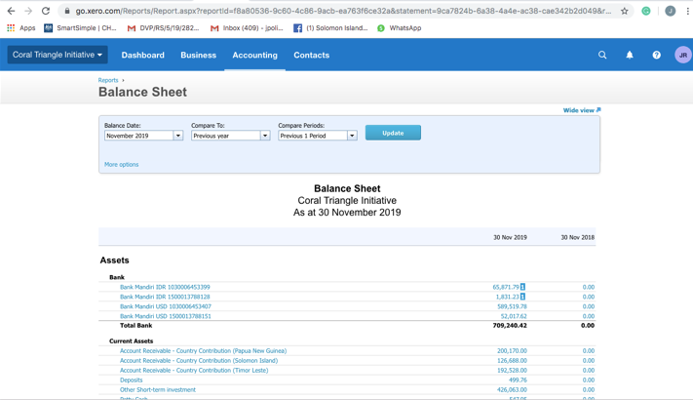
In terms of administration and book keeping, the Regional Secretariat continues to observe proper booking keeping and archiving of accounts and financial control that corresponds to the CTI-CFF standard operating procedures.

Further, the Regional Secretariat has observed and complied to the tax and manpower regulation of Indonesian government diligently.
The Balance sheet of CTI-CFF Regional Secretariat as presented in Xero.

Selection of CTI-CFF RS Executive Director and Deputy Executive Director for Corporate Services

Last May 27 and 28, 2019, the CTI-CFF’s Appointment Committee completed its selection
for the Executive Director (ED) and Deputy Executive Director for Corporate Services (DED-CS) of the Regional Secretariat of CTI-CFF.

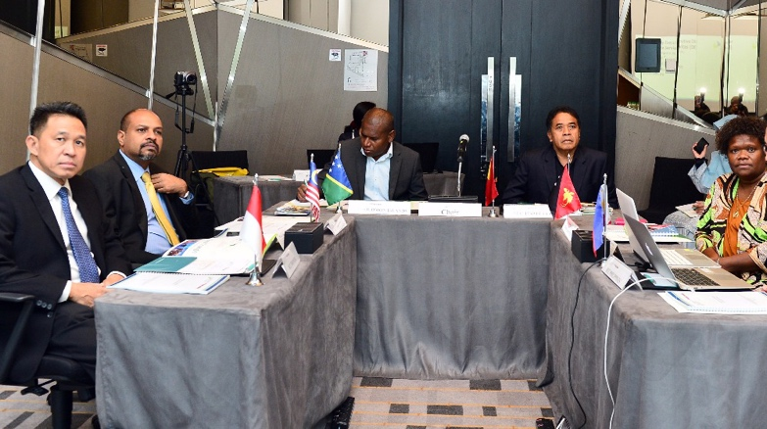
A total of five candidates from Malaysia for the position of ED as well as five candidates for DED CS – two from Indonesia, two from Papua New Guinea, and one from Timor-Leste were interviewed in Kuala Lumpur. The selected candidate for the two positions were
endorsed to the CTI-CFF Committee of Senior Officials for approval. The new ED and DED CS will be officially introduced during the 15th Senior Officials Meeting to be held in Honiara, Solomon Islands by last quarter of the year.
From left to right: The members of the Appointment Committee are Mr. Aryo Hanggono (Indonesia), Dr. K. Nagulendran (Malaysia), Mr. Patesson Lusi (Solomon Islands) as Chair; Mr. Acacio Guterres (Timor Leste) and Ms. Yvonne Tio (Papua New Guinea). Ms. Armida Andres and Ms. Nilda Baling as alternate (Philippines) joined the meeting via Skype.

The members of the Appointment Committee are Mr. Aryo Hanggono (Indonesia), Dr. K. Nagulendran (Malaysia), Ms. Yvonne Tio (Papua New Guinea), Ms. Armida Andres and Ms. Nilda Baling as alternate (Philippines) and Mr. Acacio Guterres (Timor-Leste) with Mr. Patesson Lusi (Colomon Islands) as Chair.

Renewing Host Country Agreement

In the context of the discussion of the RPOA 20 and evaluation of the implementation of Presidential Regulation No. 46 of 216 concerning Host Country Agreement between the Government of the Republic of Indonesia and the Regional Secretariat of CTI-CFF on Privileges and Immunities, the Regional Secretariat carried out a Focus Group discussion with some of the government agencies of Indonesia namely, Ministry of Marine Affairs and Fisheries, Ministry of Foreign Affairs, Directorate of General Taxes - Ministry of Finance Ministry of Law and Human Rights, State Secretariat, last April 29, 2019 in Manado, Indonesia. The FGD was intended to strengthen cooperation between the Regional Secretariat and the government of Indonesia as it renews its Host Country Agreement with the said government in 2020. The FGD also clarifed issues and concerns with regard to the privileges and immunities of the staff of the Regional Secretariat in consideration of the recognition of the UN Secretary General of CTI-CFF Regional Secretariat as an international organization.

Prior to the FGD, the Regional Secretariat, with the support of the US Department of Interior secured a legal opinion from Makarim & Taira S, an international law firm based in Jakarta, Indonesia, to further strengthen the content of the CTI-CFF Staff Policies and Procedures Manual.

Improving security and visibility

The Corporate Services Division of the Regional Secretariat has also focused its efforts in improving its infrastructure by securing CCTV on the grounds and premises of the Regional Secretariat. Also, to enhance visibility, signages were placed outside the building as well as official vehicle of the Secretariat.

Capability building

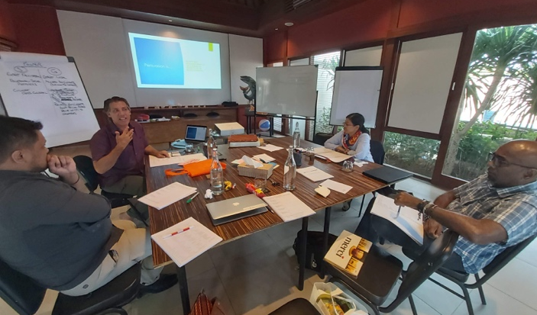
Key personnel of the CTI-CFF Regional Secretariat namely, Dr. Sharifah Nora Ibrahim, Deputy Executive Director for Program Services; Dr. Gregory Bennett, Senior Technical Program Manager; Mr. Ivan Kiagoes, Finance and Operations Manager; and Ms. Janet Rosalie Anne Polita underwent leadership training last September 27, 2019 at the Training Room of the Coral Triangle Center in Bali, Indonesia. Resource person for the activity was Mr. Robert Schout of the Powerskills Development and Training, Inc. The training was an opportunity to further learn the different leadership styles and skills set of leaders. How to address team challenges as well as how to negotiate with stakeholders were also discussed.
Mr. Robert Schout (second from left) discussed the concepts of leadership to key personnel of CTI-CFF Regional Secretariat. Photo credit: CTI-CFF RS/J. Polita

The training was made possible through the USAID RDMA, US DOI with CTC’s support.

Promoting work-life balance

Ensuring the well-being of Regional Secretariat staff, once a month Zumba, a dance exercise is being conducted on the lobby of the Regional Secretariat to promote healthy lifestyle and camaraderie among staff as well as employees working at the CTI Center in Manado, Indonesia.

Expanding partners
CTI-CFF Regional Secretariat signed a Cooperation Agreement with PT Garuda Indonesia Manado on rendering flexibility services for all Garuda flight routes and other corporate privileges served by Garuda and its group as well as Sky Team last 13 March 2019. The CTI-CFF Regional Secretariat was represented by Interim Executive Director Dr. Hendra Yusran Siry while PT Garuda Indonesia Manado was represented by General Manager Mac Fee Kindangen.

CTI-CFF Regional Secretariat through Dr. Hendra Yusran Siry inked a Cooperation Agreement with PT Garuda Indonesia through General Manager Mac Fee Kindangen. Photo credit: CTI-CFF RS.

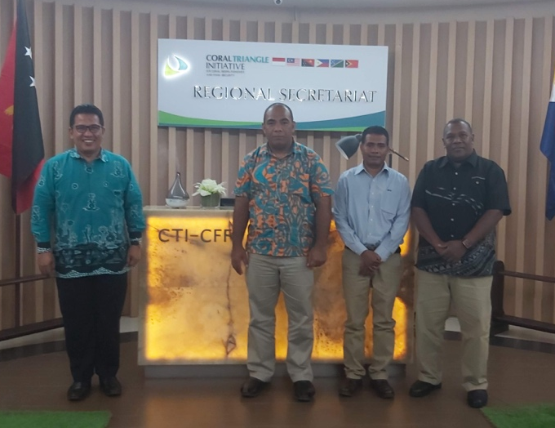
Visit of CSO Chair
Last October 7-9, 2019, the Chair of CTI-CFF CSO Dr. Melchior Mataki from Solomon Islands, the Vice-Chair of CSO represented by Mr. Horacio Guterres from Timor-Leste and IRC Chair Mr. Alick Misibini from Solomon Islands visited the CTI-CFF Regional Secretariat.

The visit was an opportunity to update the Excellencies about the current activities and discuss openly the concerns in the internal operations of the Regional Secretariat. The insights and advise provided by the Excellencies will surely help further improve the operations of the Regional Secretariat.
From left to right: Dr. Hendra Yusran Siry with Dr. Melchior Mataki, CSO Chair; Mr. Horacio Guterres, representative of CSO Vice-Chair; and Mr. Alick Misibini, IRC Chair. Photo credit: CTI-CFF RS/J. Polita

Communication and Outreach Activities

The CTI-CFF through its Regional Secretariat conducted communication and outreach activities to promote and raise awareness on the organization’s efforts to attain the goals in the Regional Plan of Action to its target and various stakeholders. Various communication activities and strategies were implemented to be able to reach a wider audience. Activities implemented were as follows:
Coral Triangle Day Celebration

This year, the CT Day celebration focused on raising awareness on the important role and contribution of gender equality in the promotion of marine conservation and protection in the Coral Triangle Region. The CTI-CFF put the spotlight on gender with the theme “Corals of Change: Paving way for gender equality in Coral Triangle.”

Particularly, the CTI-CFF Regional Secretariat in partnership with USAID Oceans, Oceanic Fishing Port Bitung and the Office of Bitung Marine and Fisheries Service conducted an orientation-workshop for 20 women from the fishing community villages in Bitung City, North Sulawesi. The activity raised awareness on gender equality as a step towards making them informed and involved in contributing to the livelihood of their family, community and economic development of Bitung.

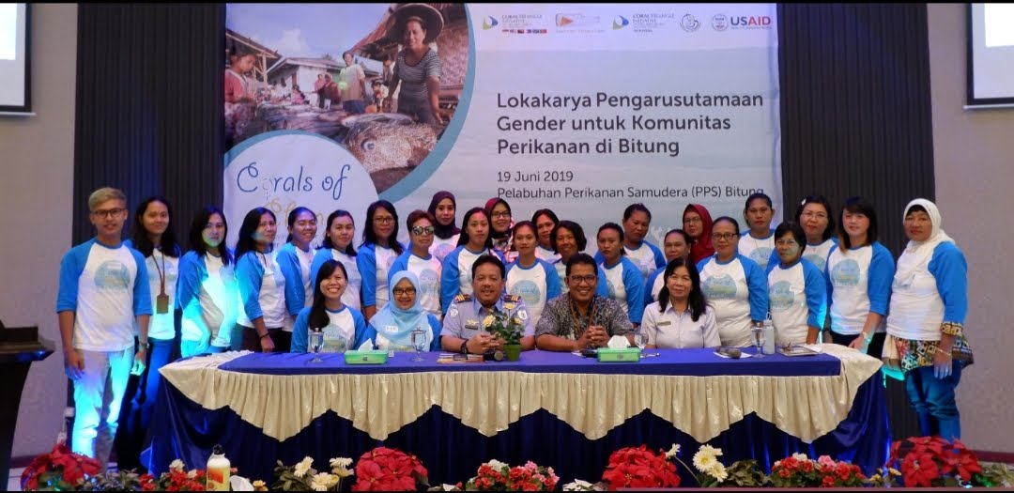
On the other hand, CT6 member countries actively implemented activities such as beach and underwater clean-up, mangrove rehabilitation, fish apartment building, sea turtle fun day, knowledge sharing session with woman scientists, waste audit and turtle release, tree planting, bicycle fun ride, slogan completion, fun run talk shows, tv guesting and other media promotion, among others. These activities were implemented in collaboration with other partner government agencies, international and local non-government organization and communities. Further, women and youth organizations in these countries played a lead role in organizing and implementing the activities.
Participants of the Workshop on Gender Mainstreaming Among Women in Fishing Community in Bitung supported by USAID Oceans and Maritime, Oceanic Fishing Port in Bitung and the Office of Bitung Marine and Fisheries Service

Bimonthly production of CTI-CFF Newsletter

The CTI-CFF Regional Secretariat continues to produce a bimonthly CTI-CFF Newsletter that features activities of the TWGs, NCCs, Development Partners and other like-minded organizations. It also highlights profile of identified experts and people who have greatly contributed in marine conservation field in their own way. The newsletter is distributed to NCCs, Development Partners and people who have took part in the various activities implemented by the Secretariat.

Preparation and dissemination of Press releases

To promote the activities/projects and other initiated efforts of the CTI-CFF to a wider public, the Regional secretariat produces and disseminates press releases to 19 online news organizations in the CT Region.

Regular updating/maintenance of CTI Website and Social Media Platforms

CTI-CFF recognizes the power of the social media to reach to a greater audience in order to build an informed public on the various issues confronting marine and coastal resources in the Coral Triangle Region and evoke participation among them in the CTI-CFF’s efforts. As such, activities of the CTI are regularly posted in CTI Website and social media platforms - Facebook, Twitter, Instagram - to further inform website visitors of latest undertakings of the CTI as well as upcoming events.

Production of IEC/Promotional Materials and development of infographics

To complement information drive in social media, the CTI-CFF produced (and will produce) information materials such as brochure and fact sheets. These print materials were made available in exhibition as well as on CTI website. In the development of the IEC materials, the following were considered, relevance, uniformity, simplicity of the content and language, accuracy of information, length of the material, cultural appropriateness and target groups.

The CTI-CFF Regional Secretariat developed infographics about e-CDT, CT Day MPAs, IYOR and Sulu-Sulawesi Seascapes. The infographics are supplemental tool to allow people to easily digest information about CTI supported initiatives through the use of visual data and statistics through proper use of color, proportion and space. The infographics were uploaded in all CTI social media accounts.

Participation in exhibit
This year, the CTI-CFF Regional Secretariat joined the 5th Diplomacy Festival (Diplofest 2019) organized by the Indonesia’s Ministry of Foreign Affairs.

The event which was held at the Celebes Convention Center drew a crowd of more than 10,000 coming from various secondary schools and universities in Makassar.

The CTI-CFF Regional Secretariat participated through and exhibition which featured information about CTI-CFF and its goals. The exhibition was also an opportunity to answer queries from the students on how they can do their part in raising awareness about marine and coastal conservation.
Dr. Hendra Yusran Siry explained to students the work of CTI-CFF. Photo credit: CTI-CFF Rs/J. Polita

Communication Outreach

Recognizing the importance of the youth in promoting the advocacies of CTI-CFF, Dr. Hendra Yusran Siry, Interim Executive Director of CTI-CFF Regional Secretariat visited Sekolah Dian Harapan in Manado North Sulawesi, Indonesia.

Dr. Siry talked with and encouraged Grade 10 students to take part in the celebration of Coral Triangle Day on June 9 as well as marine protection advocacies such as beating plastic pollution.

Mr. Heinz Wokas, Principal of Sekolah Dian Harapan thanked Dr. Siry for providing insights to the students about the importance of Coral Triangle.
Dr. Hendra Yusran Siry explained to students the work of CTI-CFF. Photo credit: CTI-CFF Rs/J. Polita

The Regional Secretariat also facilitated the participation of eight (8) students from England to be volunteers of the marine conservation activities in Manado, North Sulawesi, Indonesia. The students ages, 15 to 21 years old volunteered for two days with the Mudung Family Community and BPSPL Makassar Wilker Manado. They cleaned-up the shorelines in Malalayang and set up information boards about restrictions on littering and learned how to transplant coral at the Manado Coral Stock Centre. Outfitted in wetsuits and scuba gear, they also conducted underwater beach clean-up.

Under the guidance of Mr. Mohammad Yasir, Coordinator for Manado Work Area (Wilker), Center for Coastal and Marine Resources Management of Makassar (BPSPL Makassar), the students also learned the importance of maintaining the continuity of our coral reef and ecosystem from the dangers of ocean plastic.

Upcoming Activities for November to December 2019 activities

i. PRESOM and 15th Senior Officials Meeting
November 4-8, 2019
Honiara, Solomon Islands

Brief Description:
The conduct of the Regional workshops, i.e. MPA REX is crucial because this is the monitoring arm of the CTI to assess and evaluate the performance of the CT6 in terms of contribution to the attainment of the goals and targets of the CTI-CFF Regional Plan of Action. The MPA

Objectives: The MPA-TWG is conducting its annual meetings to review the progress of accomplishment both at the national and regional levels and jointly identify priority activities that will be endorsed to SOM for adoption/implementation, among others

- Regional Workshop on Data and Information Management (DIM)
Regional Capacity Center for Clean Seas
Bali, Indonesia
December 3-5, 2019

The objective of the activity is to foster inter-agency collaboration in sharing data and information and best practices on DIM especially in helping collecting data, provide good repository of knowledge as well as present state of the art tools that can guide and support data and information sharing on Large Marine Ecosystems (LME) as well as associated integrated coastal management (ICM) projects

The event is jointly organized by the GEF IW: LEARN and PEMSEA.

- Training on CT Atlas for CTI-CFF Regional Secretariat Key Personnel
WorldFish, Penang, Malaysia
December 2019

The training is intended to further train the key staff of CTI-CFF Regional Secretariat handling the CT Atlas mainly, the IT Officer and Communication and Information Manager on the management of the CT Atlas.

